Chapter 2: Assessment of the Pacific cod stock   
in the Gulf of Alaska

Peter-John F. Hulson, Steven J. Barbeaux, Bridget Ferriss, Katy Echave, Julie Nielsen, Susanne McDermott, Ben Laurel, Alisa Abookire, Ingrid Spies and S. Kalei Shotwell

January 2026

This report may be cited as: Hulson, P.-J. F., S. J. Barbeaux, B. Ferriss, K. Echave, J. Nielsen, S. McDermott, B. Laurel, A. Abookire, I. Spies, and S. K. Shotwell. 2026. Assessment of the Pacific cod stock in the Gulf of Alaska. North Pacific Fishery Management Council, Anchorage, AK. Available from <https://www.npfmc.org/library/safe-reports/>.

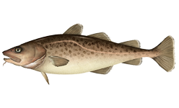

*With contributions from:*

Mike Litzow, Kimberly Rand, Charlotte Levy, and Muyin Wang

# Executive Summary

Pacific cod in the Gulf of Alaska are assessed on an annual stock assessment schedule to coincide with the availability of new survey data. We use a statistical age-structured model as the primary assessment tool for Gulf of Alaska Pacific cod which qualifies as a Tier 3 stock. This assessment consists of a population model, which uses survey and fishery data to generate a historical time series of population estimates, and a projection model, which uses results from the population model to predict future population estimates and recommended harvest levels. Model input files, additional plots and model diagnostics, and presentations pertaining to this assessment can be found at this [link](https://afsc-assessments.github.io/goapcod/2025_Assessment/January_Model/).

## Summary of Changes in Assessment Inputs

Relative to last year’s assessment, the following changes have been made in the current assessment:

### Changes in the input data

1. Federal and state catch data for 2024 were updated and preliminary federal and state catch data for 2025 were included;
2. Commercial federal and state fishery size composition data for 2024 were updated, and preliminary commercial federal and state fishery size composition data for 2025 were included;
3. Commercial federal conditional age-at-length data for 2024 were included;
4. AFSC longline survey Pacific cod abundance index and length composition data for the GOA for 2025 were included;
5. AFSC bottom trawl survey abundance index and length composition data for 2025 were included;

### Changes in the methodology

The methodology remains the same as Model 24.0 accepted in 2024.

## Summary of Results

The stock appears to be recovering from low levels with the 2026 the stock estimated to be nearly equal to the *BMSY* proxy of *B35%* (the estimate is *B33.1%*). By the FMP, being below *B40%* categorizes the stock status as being in sub-tier “b” of Tier 3. Under Tier 3b, the estimated maximum allowable ABC is 41,520 t. This ABC is 29% larger than the 2025 ABC of 32,141 t and 37% larger than the 2026 ABC projected in last year’s assessment due to updated survey data and an increase in the estimated stock status. In Tier 3b, stock status increases along the harvest control rule ramp results in increases to the allowable fishing mortality rate and affects both the ABC and OFL. The corresponding reference values are summarized in the following table, with the recommended ABC and OFL values in bold. The stock is not subject to overfishing, is not currently overfished, nor is it approaching a condition of being overfished.

|  |  |  |  |  |
| --- | --- | --- | --- | --- |
| **Quantity** | As estimated or *specified last* year for: | | As estimated or *specified this* year for: | |
| 2025 | 2026 | 2026 | 2027 |
| *M* (natural mortality rate) | 0.49* | 0.49* | 0.5* | 0.5* |
| Tier | 3b | 3b | 3b | 3b |
| Projected total (age 0+) biomass (t) | 177,497 | 200,521 | 182,156 | 186,118 |
| Female spawning biomass (t) |  |  |  |  |
| Projected | 46,920 | 44,674 | 52,772 | 45,838 |
|  |  |  |  |  |
| *B100%* | 163,585 | 163,585 | 159,595 | 159,595 |
| *B40%* | 65,434 | 65,434 | 63,838 | 63,838 |
| *B35%* | 57,255 | 57,255 | 55,858 | 55,858 |
| *FOFL* | 0.57 | 0.51 | 0.68 | 0.54 |
| *maxFABC* | 0.46 | 0.43 | 0.54 | 0.47 |
| *FABC* | 0.46 | 0.43 | 0.54 | 0.47 |
| OFL (t) | 38,688 | 33,099 | **49,782** | 38,812 |
| maxABC (t) | 32,141 | 30,193 | 41,520 | 32,209 |
| ABC (t) | 32,141 | 30,193 | **41,520** | 32,209 |
| **Status** | As determined *last* year for: | | As determined *this* year for: | |
| 2023 | 2024 | 2024 | 2025 |
| Overfishing | No | n/a | No | n/a |
| Overfished | n/a | No | n/a | No |
| Approaching overfished | n/a | No | n/a | No |

*\*Base natural mortality M varies between 0.5 and 0.84*

*\*\* Assumed 2025 catch to be the 2025 ABC. For 2027 projections the 2026 catch was assumed to be at the projected ABC.*

## Area apportionment

Using the recommended random effects model (described in the *Area Allocation of Harvests* section as applied within the rema R-package, Sullivan *et al.* 2022) with the trawl survey biomass estimates through 2025, the Biologically informed Recommended Distributions (BRD) are:

|  |  |  |  |  |
| --- | --- | --- | --- | --- |
|  | Western | Central | Eastern | Total |
| Area apportionment | 24.80% | 69.20% | 6% | 100% |
| 2026 BRD | 10,297 | 28,732 | 2,491 | 41,520 |
| 2027 BRD | 7,987 | 22,289 | 1,933 | 32,209 |

# Introduction

This document is an update from the 2024 assessment and includes newly available data. The model used for management recommendations is the same as the last accepted model in 2024, Model 24.0. For brevity we included the document sections in which data or model results changed; other unchanged sections are available [here](https://files.npfmc.org/SAFE/2024/GOApcod.pdf).

# Fishery

## Fishery history and management measures

For a full description of the fishery history and management measures see Hulson *et al.* 2022. Catches of Pacific cod since 1991 by gear type and jurisdiction are shown in Table 2.1; catches prior to that are listed in Thompson *et al.* (2011). Presently, the Pacific cod stock is exploited by a variety of fisheries, including trawl, longline, pot, and jig components; Figure 2.1 shows landings by gear since 1977. The history of Total Allowable Catch (TAC), Acceptable Biological Catch (ABC), Overfishing Level (OFL), and State of Alaska Guideline Harvest Levels (GHL) are summarized since 1991 and compared with the time series of aggregate commercial catches in Table 2.2 (data prior to 1991 are shown in Hulson *et al.* 2022). The complete history of allocation (in percentage terms) by regulatory area within the GOA is shown in Table 2.3. Catch reported in Tables 2.1 and 2.2 include discarded Pacific cod, estimated retained and discarded amounts are shown in Table 2.4.

## Recent fishery performance

Figure 2.2 shows the distribution of observed catch for the most recent year of complete catch data (2024) for the three major gear types, as well as the distinction between observed and electronic monitored catch. Cumulative catch by week in 2025 is comparable to previous years catch across the gear types (Figure 2.3).

In 2025 the federal TAC was set at 23,670 t and state GHL set at 8,471 t (Table 2.2). As of December 8, 2025 a total of 26,947 t (84% of the ABC) has been harvested (Table 2.1); State fisheries have harvested 7,344 t (87% of the GHL) and federal fisheries 19,603 t (83% of the TAC). In 2025 41% of the Pacific cod catch was by trawl, 32% by pot gear, and 24% by longline, while jig and other gear harvested 3% (Table 2.1).

# Data

This section describes updates to the data used in the current assessment. The following table and Figure 2.4 present the data included in this assessment (the years shown in bold font are those that are new to this assessment).

|  |  |  |  |
| --- | --- | --- | --- |
| **Data** | **Source** | **Type** | **Years** |
| Federal and state fishery catch, by gear type (trawl, pot, and longline) | AKFIN | Metric tons | 1977 – **2025** |
| Federal and state fishery catch-at-length, by gear type | AKFIN, ADF&G | Frequency observed at length (in cm) | 1977 – **2025** |
| GOA NMFS bottom trawl survey abundance | AKFIN | Total numbers | 1990 – **2025** |
| AFSC Sablefish Longline survey Pacific cod Relative Population Numbers | AKFIN | RPN | 1990 – **2025** |
| GOA NMFS bottom trawl survey length composition | AKFIN | Number at length (in cm) | 1990 – **2025** |
| GOA NMFS bottom trawl survey conditional age-at-length | AKFIN | Proportion age at length | 1990 – 2023 |
| AFSC Sablefish Longline survey Pacific Cod length composition | AKFIN | RPN at length (in cm) | 1990 – **2025** |
| Federal fishery conditional age-at-length | AKFIN | proportion age at length | 2007 – **2024** |
| CFSR bottom temperature indices | National Center for Atmospheric Research | temperature anomaly at mean depth for P. cod size bins | 1979 – 2024 |

## Fishery

### Catch Biomass

Total catches for the period 1991-2025 are shown for the three main gear types in Table 2.1, with the 2025 values through December 8, 2025. The current year’s catch within the assessment model is assumed to reach the full Total Allowable Catch (TAC) and state Guideline Harvest Level (GHL). Three fisheries were modeled (by gear categories); trawl (all trawl types), longline (longline and jig) and pot.

### Length Composition

Fishery length compositions are available by fishery from 1977 through December of 2025 (Figure 2.4). Due to the selectivity of the fisheries, these length compositions are not informative about incoming year classes and primarily catch adult Pacific cod.

### Age composition

Age data collected since 2007 from the commercial fishery were used to develop an annual conditional age-at-length matrix for each fishery, this data was updated to include new 2024 information (Figure 2.4).

## Surveys

### AFSC bottom trawl survey

In 2025, the scientists from the AFSC transitioned to a new stratified random design for this survey. The new design changed from the previous 59 strata defined by INPFC management area, depth, and general habitat type (shelf, gully, and slope) to 28 strata defined by NMFS management area and depth. We describe results of analysis comparing historical bottom trawl survey data using the restratified design in Appendix 2.2 and noted a negligible impact on Pacific cod estimates compared to the previous design. We note that for 2025 the survey was conducted with two chartered vessels completing 431 stations and that this represented an 18% reduction compared to the number of stations sampled in 2023. The number of stations sampled in the GOA bottom trawl survey in 2025 were the fewest since 1990, including 2001 when the Eastern GOA was not sampled.

The spatial distribution of Pacific cod catch in the 2025 trawl survey was comparable to the most recent surveys (in 2023 and 2021, Figure 2.5). In general, the 2025 survey resulted in stations with higher Pacific cod catch than those from 2021 and 2023.

#### Indices

Since the time-series low in 2017, the Pacific cod biomass and abundance estimates from the bottom trawl survey suggest an increasing trend in the population (Table 2.5). Compared to the 2023 survey, the 2025 trawl survey biomass estimate increased by 39.2% and the abundance estimate increased by 49.6%. These increases in biomass and abundance were driven by overall increases in station density observations, rather than a few high-density stations. Nonetheless, the coefficient of variation (CV) estimate was 23% which is larger than recent CVs but within the range estimated for other years of the time-series. This increase in CV is likely influenced by the reduction in the number of stations sampled in 2025. The restratified survey design resulted in negligible differences in uncertainty (Appendix 2.2).

#### Length Composition

The bottom trawl survey 2025 length composition was observed to be bi-modal, with a mode at 15-20 cm (representing catches of age-1 cod, which would be the 2024 year class) and a mode at 35-70 cm (fishery and survey length composition figures can be found in the SS3 plots at the link provided for additional resources in the *Executive* Summary section, and [here](https://afsc-assessments.github.io/goapcod/2025_Assessment/January_Model/figures/_SS_output_LenComp.html)).

#### Age Composition

Otoliths for bottom trawl survey age composition estimation were collected in each survey and were used as conditional age-at-length data within the GOA Pacific cod assessment. Data from the 2025 survey were unavailable (trawl-survey age data were the same as in the 2024 assessment).

### AFSC longline survey

Conducting the AFSC longline survey involves sampling the continental slope and major gullies in the GOA, providing data to calculate relative abundance in this area (Rutecki et al. 2016, Siwicke and Malecha 2024). The survey is primarily directed at sablefish, but also catches considerable numbers of Pacific cod. The survey was conducted in 2025 after missing a year in 2024.

Pacific cod catch in the longline survey primarily occur in the Western and Central GOA (Figure 2.6). There were consistent increases in catch in the Western and Central GOA in 2025 compared to 2023 for the majority of stations, with a large decrease at a single station in the Eastern GOA.

#### Abundance index

The AFSC longline survey index indicates a generally increasing trend since the time-series low in 2019 (Table 2.5). The 2025 estimate declined slightly (5%) compared to the most recent 2023 value. The decline was primarily due to densities observed from the Eastern GOA subregion (the Western and Central GOA subregions increased compared to 2023, for subregional RPN estimates please see slide 14 in this [presentation](chrome-extension://efaidnbmnnnibpcajpcglclefindmkaj/https:/meetings.npfmc.org/CommentReview/DownloadFile?p=963e9894-bf47-4125-84e4-d3a5a47d46b9.pdf&fileName=Longline%20Survey%20pres.pdf) made to the Groundfish Plan Team in September 2025). This decline was not due to the redesign of the survey by dropping several stations (see slide 8 of the linked presentation).

The AFSC longline survey RPN index is computed by multiplying the average station density (catch per hook) within a stratum by the stratum area size (where the stratum is based upon geographic region and depth). Upon further investigation, it was discovered that the magnitude of Eastern GOA RPN is driven by the area size for the 150-200m depth stratum, which is larger in the Eastern GOA than the Central or Western GOA. This has resulted in a distribution of RPN across the GOA that is inconsistent with the distribution of abundance as observed from the AFSC bottom trawl survey; Eastern GOA RPN represents an average of 33% of the total GOA RPN across the time-series of the index, whereas the AFSC bottom trawl survey has observed Eastern GOA cod abundance that is, on average, less than 5% of the total GOA abundance across the time-series. Ultimately, this has resulted in a subregion which contains the fewest stations that catch cod (Figure 2.6) having the greatest influence on the GOA-wide RPN index. Further, the decrease in the Eastern GOA RPN index in 2025 compared to 2023 was driven by reduced catch at a single station (Figure 2.6).

Upon computing the mean numbers CPUE from the AFSC longline survey we found that the GOA-wide CPUE increased by 7% in 2025 compared to 2023. Based upon the discovery of the influence of Eastern GOA RPN on the total GOA RPN index, prior to the next full assessment we will be investigating a new method to compute the AFSC longline index. Because this is an update assessment, we continue to use the AFSC longline survey RPN index in its current form.

#### Length composition

The observed length composition from the 2025 longline survey was unimodal and consistent with previous survey length compositions, with a peak at 60 cm.

## Other indicators

There are several indicators that are monitored but not fit in the assessment model that provide auxiliary information on the GOA cod stock. We include those within the following sections.

### Laurel and Litzow age-0 index

Beach seine sampling of age-0 cod was conducted in 2025. The beach seine age-0 CPUE index resulted in estimated values in 2025 that were very similar to the 2024 and 2023 estimates, all which are around 40% smaller than the time-series mean (top right panel of Figure 2.7).

### Alaska Department of Fish and Game bottom trawl survey

The Alaska Department of Fish and Game (ADFG) bottom trawl survey index suggests an increasing trend in the Pacific cod population since the time-series low in 2016 (top left panel of Figure 2.7). In 2025 the ADFG bottom trawl survey CPUE of cod numbers increased by 14.7% compared to 2024.

### Commercial fishery indices

Non-targeted catch of Pacific cod in other directed fisheries was examined as an indicator of population trends. We examine two disparate fisheries to evaluate trends in incidental catch of Pacific cod: the pelagic walleye pollock fishery and the bottom trawl shallow water flatfish fishery. The occurrence of Pacific cod in the pelagic pollock fishery appears to be an abundance indicator for 2-year-old Pacific cod, which are thought to be more pelagic. As an index of recruitment abundance, we tracked the incidence of occurrence as proportion of hauls with cod in the central GOA pollock A season. The shallow water flatfish fishery tracked a larger portion of the adult population of Pacific cod. As an index of the adult population abundance, we track the catch rates in tons of Pacific cod per ton of all species caught in the shallow water flatfish fishery. For the walleye pollock fishery in the central GOA, abundance of small cod in pelagic trawls has exhibited an alternating trend in the most recent 5 years, with larger catches in 2022 and 2024 and smaller catches in 2021, 2023, and 2025 (bottom right panel of Figure 2.7). The catch of Pacific cod in the shallow water flatfish fisheries has trended up since the time series low in 2017. The 2024 and 2025 values are the largest in the recent time series and only smaller than the 2014 value since 2008 (bottom right panel of Figure 2.7). It should be noted that none of these indices are controlled for gear, vessel, effort, or fishing practice changes.

## Environmental indices

The Climate Forecast System Reanalysis (CFSR) temperature index has been discontinued and was not available for 2025. When an environmental index is not available in a certain year the SS3 protocol is to set that year’s index value at 0, meaning that the mean parameter estimate for that year is used. An alternative environmental index will be used in the next full assessment.

# Analytic Approach

We use Model 24.0 in this assessment (described in Hulson *et al.* 2024). The model for this year was run in SS3 version 3.30.22.1 (the same version as the 2024 assessment, Methot and Wetzell 2013). The SS3 control and forecast files for this year’s model can be found at the link provided in the *Executive Summary* section of this document.

# Results

## Model Evaluation

In the 2024 assessment a full suite of model diagnostics and sensitivities were provided for Model 24.0. In the next full assessment when alternative models are explored these will be provided within this document. Model diagnostics and sensitivities that were provided in the 2024 assessment and applied to the 2025 update assessment that are not contained in this document are provided in the link in the *Executive Section*. As with the results in the 2024 assessment, the update here indicate that the likelihoods appear well defined with acceptably low final gradients (the final gradient was 6.45e-6) and asymptotic approximations of parameter variances. Convergence of Model 24.0 was further examined by “jittering” starting parameters by a factor of 5% over 50 runs to evaluate if models had converged to local minima. Jitter analysis revealed that Model 24.0 was insensitive to perturbations of parameter start values on the order of 5% with a total of 46 of the 50 jitter runs converged and 74% of the converged models resulting in estimates at the lowest MLE from the accepted models.

As in 2024, Model 24.0 configuration resulted in acceptable fits and parameter estimates (Table 2.6). Estimates of abundance and recruitment compared favorably to previous assessments and do not result in any concerning retrospective patterns (Figure 2.8 and 2.9). On the whole, Model 24.0 fits the AFSC bottom trawl and longline survey indices reasonably well (Figure 2.10). However, positive residuals have persisted in the fit to the longline survey since 2018 and the model does not fit the 2025 increase in bottom trawl survey abundance. The aggregated fit from Model 24.0 to the fishery length composition data and one-step-ahead residuals are acceptable but appeared to have a few outlier residuals in proportions at length (Figure 2.11). The fits to the survey age composition data in aggregate were also acceptable but also had some outliers present in the one-step ahead residuals (Figure 2.12). The standard SS3 plots, which contain additional results, can be found at the link provided in the *Executive Summary* section of this document.

## Time Series Results

### Definitions

The annual biomass estimates presented were: total biomass (the biomass at the start of the year of all fish aged 0 years or greater in a given year) and spawning biomass (the estimated biomass of mature females at the start of the year). Recruitment is defined as the number of age-0 fish by year.

### Biomass

Total biomass estimates show a long decline from their peak in 1988 (Table 2.7 and Figure 2.13) to a low in 2006 and then an increase to another peak in 2014, after which there was a sharp decline through 2018 followed by a slight increase through 2024. Total biomass in 2025 is estimated to be essentially unchanged from 2024.

Spawning biomass (Table 2.7 and Figure 2.13) shows a similar trend of decline since the late 1980s with a peak in 1989 to a low in 2008. There was then a short increase in spawning biomass coincident with the maturation of the 2005-2008 year classes through 2014, after which the decline continued to lowest level in 2019 and 2020. The spawning biomass then slightly increased through 2022 and has remained steady through 2025. Compared to the most recent assessment in 2024, the current Model 24.0 results in slightly smaller spawning biomass estimates from 2015 to 2021, then larger after 2022 (Figure 2.8).

### Recruitment and Numbers-at-Age

The recruitment predictions in Model 24.0 (Table 2.8 and Figure 2.14) show above average recruitment for most of the 1980s, below average recruitment from the mid-1990s to mid-2000s, above average recruitment from the mid-2000s to 2013, and below average recruitment since. Compared to the most recent assessment in 2024, the current Model 24.0 results in larger estimates of the 2020 and 2021 year classes, and smaller 2023 and 2024 year classes (Figure 2.8).

### Fishing Mortality

Fishing mortality appears to have increased steadily with the decline in abundance from 1990 through a peak in 2008 with continued high fishing mortality through 2017 (Table 2.9 and Figure 2.15). 2017 had the highest total exploitation rate of the time series. The period between 1990 and 2008 saw both a decline in recruitment paired with increases in catch. The period of increasing fishing mortality was mainly attributed to the rise in the pot fishery, which also shows the largest increase in continuous F (Figure 2.15). In 2018 through 2020 there was a sharp decrease in fishing mortality coincident with the drastic cuts in ABC and closure of the federal directed fishery in 2020. In 2021 with the reopening of the federal fishery mortality once again increased, but remained lower than observed in the previous decade prior to 2017. In retrospect, the phase plane plots (Figure 2.16) show that F was estimated to have been above the ABC control rule advised levels from 2015 to 2017 and biomass has been below *B35%*since 2017 and projected to continue to be below through 2027. It should be noted that this plot shows current model predictions, not what the past assessments had estimated.

## Harvest Recommendations

### Amendment 56 Reference Points

Amendment 56 to the GOA Groundfish Fishery Management Plan (FMP) defines the “overfishing level” (OFL), the fishing mortality rate used to set OFL (*FOFL*), the maximum permissible ABC, and the fishing mortality rate used to set the maximum permissible ABC. The fishing mortality rate used to set ABC (*FABC*) may be less than this maximum permissible level, but not greater. Because reliable estimates of reference points related to maximum sustainable yield (MSY) are currently not available but reliable estimates of reference points related to spawning per recruit are available, Pacific cod in the GOA have generally been managed under Tier 3 of Amendment 56. Tier 3 uses the following reference points: *B40%*, equal to 40% of the equilibrium spawning biomass that would be obtained in the absence of fishing; *F35%*, equal to the fishing mortality rate that reduces the equilibrium level of spawning per recruit to 35% of the level that would be obtained in the absence of fishing; and *F40%*, equal to the fishing mortality rate that reduces the equilibrium level of spawning per recruit to 40% of the level that would be obtained in the absence of fishing. The following formulae apply under Tier 3:

*3a) Stock status:* *B/B40%* > 1

*FOFL* = *F35%*

*FABC* < *F40%*

*3b) Stock status:* 0.05 < *B/B40%* < 1

*FOFL* = *F35%* × (*B/B40%* - 0.05) × 1/0.95

*FABC* < *F40%* × (*B/B40%* - 0.05) × 1/0.95

*3c) Stock status:* *B/B40%* < 0.05

*FOFL* = 0

*FABC* = 0

Other useful biomass reference points which can be calculated using this assumption are *B100%* and *B35%*, defined analogously to *B40%*. These reference points are estimated as follows, based on this year’s model, Model 24.0:

|  |  |  |  |
| --- | --- | --- | --- |
| Reference point: | *B35%* | *B40%* | *B100%* |
| Spawning biomass: | 55,858 t | 63,838 t | 159,595 t |

For a stock exploited by multiple gear types, estimation of *F35%* and *F40%* requires an assumption regarding the apportionment of fishing mortality among those gear types. For this assessment, the apportionment was based on this year’s model’s estimates of fishing mortality by gear for the five most recent complete years of data.

### Specification of OFL and Maximum Permissible ABC

For Model 24.0 spawning biomass for 2026 is estimated by this year’s model to be 52,772 t at the start of the year. This is below the *B40%* value of 63,838 t, thereby placing Pacific cod in sub-tier “b” of Tier 3. Given this, the model estimates OFL, maximum permissible ABC, and the associated fishing mortality rates for 2026 and 2027 as follows (2027 values are predicated on the assumption of the full TAC and GHL being taken in 2025 and that the 2026 catch will be at maximum ABC in the projection):

|  |  |  |  |
| --- | --- | --- | --- |
| Units | Year | Overfishing  Level (OFL) | Maximum  Permissible ABC |
| Harvest amount | 2026 | 49,782 | 41,520 |
| Harvest amount | 2027 | 38,812 | 32,209 |
| Fishing mortality rate | 2026 | 0.68 | 0.54 |
| Fishing mortality rate | 2027 | 0.54 | 0.47 |

The age 0+ biomass projections for 2026 and 2027 from this year’s model are 182,156 t and 186,118 t, respectively.

### Risk Table and ABC Recommendation

#### Risk table summary

The risk table is included to identify considerations that introduce additional risk to the recommended ABC that are not explicitly captured within the stock assessment model for the GOA cod stock and could support a reduction in the recommended ABC. These risks are described in the following and are, in part, aided by a synthesis and interpretation of the most recent ecosystem and socioeconomic information available for GOA Pacific cod from the Ecosystem and Socioeconomic Profile (ESP, Appendix 2.1) and the GOA Ecosystem Status Report (ESR, Ferriss 2026).

These results are summarized in the table below:

|  |  |  |  |
| --- | --- | --- | --- |
| *Assessment-related Considerations* | *Population Dynamics Considerations* | *Ecosystem Considerations* | *Fishery-informed Stock Considerations* |
| **Level 1:** Normal | **Level 1:** Normal | **Level 2:** Increased Concern | **Level 1:** Normal |
| Model 24.0 does not have a concerning retrospective pattern and fits the available data well | Stock continues to experience historically low spawning biomass coupled with below average recruitment | Prolonged warm ocean temperatures throughout the water column in 2025, and concerns of prey base availability, may adversely impact adult Pacific cod biological status in 2026. | Fishery performance indicators are consistent with previous years |

The following sections contain further details supporting these risk levels.

#### Assessment-related considerations:

*Risk Level 1: Normal*

* The updated Model 24.0 does not show a strong retrospective pattern in recent estimates of spawning biomass, either in the data retrospective or in the model retrospective across recent assessments (Figure 2.9). The retrospective pattern in spawning biomass in the current assessment is negative, which means that as years of data were added to the model the estimates of spawning biomass increase.
* Model 24.0 is, in general, responding appropriately to observed data sources. While the model fits to the indices fall within the 2025 confidence intervals, the model underfits the trawl survey mean and overfits the longline survey mean. Given these results, the estimates of spawning and total biomass from Model 24.0 as applied with updated data though 2025 responds to and reflects the balance between the changes in the index data compared to previous assessments.
* We continue to note that the projection model uses mean recruitment from 1977 – 2023 to project biomass into future years while Model 24.0 estimates below average recruitment since 2014. Therefore, given these recent low recruitment estimates it is likely that the forecasted spawning biomass is overly optimistic. However, the effect on the two-year projections that result in ABC and OFL recommendations is not largely impacted by this recruitment assumption, as the year classes that are assumed to be at mean recruitment aren’t contributing much to the overall level of spawning biomass in the short term.
* Auxiliary information on recruitment from non-target fishery sources and the beach seine survey of age-0 fish surveys suggest above average 2020- and 2022-year classes, followed by below average years classes after 2023. Within the observations of length composition (and age composition) from the AFSC bottom trawl survey these relatively stronger year classes are present, but the model estimates lower abundance of these year classes than have been observed. Therefore, we note this inconsistency between the assessment results and observations, but make the point that this inconsistency would not result in increased risk that the stock is smaller in 2026 than projected by Model 24.0, rather, that the assessment may be underestimating the magnitude of recruitment since 2014.
* A sharp decline in maximum ABC in the two-year projection (2027) compared to the one-year projection (2026) resulted from Model 24.0 after updating data through 2025. This decline is the result of declining abundance estimates of the 2020 and 2021 year-classes in the forecasted population in combination with moving down the ramp of the NPFMC Harvest Control Rule (HCR) for Tier 3b status. While this decline is notable, increases in two-year ABC in recent assessments have resulted as well. For example, the two-year projected ABC in 2022 was 61% larger than the one-year projected ABC for 2021 due to moving up the ramp of the HCR (Barbeaux et al. 2020). We make this note to highlight that this is not an additional risk to the recommended 2026 ABC but rather observe that this is a feature of the HCR ramp for Tier 3b status as applied to the population characteristics of GOA Pacific cod.
* We continue to rate the assessment considerations category at risk level 1 – typical to moderately increased concern due to 1) Model 24.0 fitting the available data reasonably well, 2) lack of a retrospective pattern, and 3) the limited impact of projected mean recruitment that is higher than the past decade of estimated recruitments on 2-year ABC and OFL recommendations.

#### Population dynamics considerations:

*Risk Level 1: Normal*

* Female spawning biomass is estimated to decrease over the next 3 years, then increase in the medium-term once the projected year classes (i.e., those after 2025 that are based on mean recruitment since 1977) begin contributing to the SSB. Total biomass is estimated to increase through 2030.
* The 2025 observations of population scale from both the fitted data sources (bottom trawl survey and longline survey) and the monitored data sources (ADFG trawl survey and shallow water flatfish incidental catch) continue to indicate a generally increasing trend in population size since historically low levels.
* Spawning conditions were considered below average to low in 2025. This is based on an uptick of heatwave events during the spawning period in 2025 (Appendix 2.1: S. Barbeaux) and low habitat suitability index (based on temperatures at GAK 1 of the Seward line from January to April, Appendix 2.1: L. Rogers). While these conditions are not favorable for cod recruitment, a relatively lower 2025 year class would have little impact on the recommended 2026 ABC.
* Overall, the stock has yet to recover in the GOA to historical levels and Model 24.0 continues to estimate below average recruitment of recent year-classes.
* In past assessments the low levels of spawning biomass and below average recruitment have been used to rate the population dynamics considerations category at risk level 2 – increased concern. It must be noted that these evaluations of risk are based upon the assessment model results and because these risks are obtained from evaluation of the assessment model results, they are, by definition, included within the assessment process and thus mitigated through the application of the stock status within the HCR. Therefore, in this assessment we reduce the risk level for the population dynamics considerations category to risk level 1 – typical to moderately increased concern. We make this reduction in risk level while recognizing that the GOA cod stock remains in a undesirable stock status.

#### Ecosystem considerations:

*Risk Level 2: Increased Concern*

* Prolonged periods of above average temperatures, including periods in moderate marine heatwave status, through the winter, early spring, late summer, and fall, throughout the water column on the shelf and offshore in the gyre (Lemagie and Bell, Lemagie and Callahan, and Ocean Temperature Synthesis, in Ferriss 2026) may lead to higher metabolic demands of adult cod (requiring increased prey base to support their energetic needs, Appendix 2.1: Adams).
* Juvenile cod (<50cm) body condition decreased slightly and remained below average while adult Pacific cod (>50cm) decreased from average to below average in 2025 (Appendix 2.1: Rohan, Prohaska and Rohan). This decrease in body condition may imply below average prey availability.
* There are mixed signals in the indicators for prey base. An adequate prey base is supported by observations of above-average euphausiid spring biomass in the northern GOA (Hopcroft, in Ferriss 2026), elevated herring ocean stocks in SE Alaska (Dressel et al., in Ferriss 2026), elevated capelin presence in seabird diets (Whelan et al., in Ferriss 2026), good reproductive success of fish-eating seabirds (Appendix 2.1: Zador, Drummond et al., in Ferriss 2026), and an increase in hermit crabs (representing benthic prey) in the western GOA (Whitehouse and Aydin, in Ferriss 2026). An inadequate prey base is supported by observations of continued low presence of P. sandlance in seabird diets in the northern GOA (Whelan et al., in Ferriss 2026), reduced biomass of brittle stars and echinoderms (representing benthic prey, Whitehouse and Aydin, in Ferriss 2026) and average to below-average pandalid shrimp (Friedman, in Ferriss 2026) in the western GOA.
* The spring phytoplankton bloom (satellite derived mean chlorophyll *a*) was slightly above average (Gann, in Ferriss 2026), while the peak timing of the spring bloom has stabilized somewhat since 2020 and is at the average for the time series (Appendix 2.1: Callahan). This may provide a buffer to increased metabolic demands in warming temperatures. However, the phytoplankton community size index observed along Seward Line was dominated by smaller-cell dominated spring bloom, comparable to recent marine heatwave years (in contrast to 2021-2024), indicating a less efficient transfer of energy up the foodweb (Hennon, in Ferriss 2026).
* Competition and predation indicators of early juvenile Pacific cod show mixed signals with low abundance of apex fish predators such as arrowtooth flounder and Pacific halibut (Whitehouse, in Ferriss 2026), slight increase in projected biomass consumed from the CEATTLE multispecies model (Appendix 2.1: Adams), and steadily increasing population of Steller sea lions in the GOA (Appendix 2.1: Sweeney).
* Overall, due to the prolonged periods of above average temperatures throughout the water column coupled with the decrease to below average body condition for adult Pacific cod as an indication of prey availability in 2025 we increase the risk level for ecosystem considerations to risk level 2 – increased concern. These conditions, while not as extreme as observed during the heatwave years, still present an increased risk to the adult population that comprises the 2026 recommended ABC.

#### Fishery-informed stock considerations:

*Risk Level 1: Normal*

* Where data were available, catch-per-unit effort measures in the GOA fisheries showed mixed signals that are consistent with previous years.
* It should be noted that catch levels and fishery participation have been low over the past 5 years in comparison with pre fishery closure years due to the lower population size resulting in lower catch limits than historical limits.
* Bycatch in other fisheries still remain low compared to fisheries prior to the 2014-2016 marine heatwave, with the exception of the shallow water flatfish fishery, within which we have noted that Pacific cod catch has increased.
* We continue to rate the fishery-informed stock considerations at risk level 1 – no apparent concerns.

#### ABC recommendation

While the largest score of the risk table is level 2, we recommend that the ABC be set based on the FMP HCR. The Tier 3b stock status includes an adjustment that reduces the OFL and ABC and this builds in precaution to help the stock increase to above *BMSY* (*B35%* in this case). Nonetheless, we acknowledge the potential increased risk from unknown factors outside of data and considerations included in the stock assessment model. Warmer than average temperatures through most of 2025 may impact population productivity even though the spawning biomass is near the *BMSY* estimate.

In terms of the marine heatwave index, similar conditions to those in 2025 have been observed in recent years, notably in 2014 and again in 2019. After 2014, the severe marine heatwave hit in 2015 and 2016 during which the population collapsed. It must be noted that the magnitude of the population was much different in 2014 prior to the severe marine heatwave event compared to 2025; the spawning biomass in 2014 (as estimated by the 2014 assessment) was 250% larger than the spawning biomass estimated in 2025 by Model 24.0, and the adopted ABC for 2015 (the largest ABC on record) was nearly 150% larger than the recommended ABC for 2026. Rescaling the 2015 and 2026 ABCs with the total biomass estimated in these years by Model 24.0 results in an ABC that was 24% larger in 2015 compared to the recommended 2026 ABC. In other words, the 2026 ABC is buffered by an additional 24% compared to the ABC that would have resulted given the current stock status and assessment model structure as compared to that which existed in 2015. After 2019 the marine heatwave did not persist and we have since observed and estimated that the adult population trend continues to increase after 2019. However, the 2019 year class was the smallest of the time series. We suspect that it is likely that the 2025 year class will be small due to the 2025 conditions, however, it is less clear as to the impact of the conditions in 2025 on the adult population that comprises the 2026 recommended ABC. It is also unknown whether the conditions we observed in 2025 will continue into 2026, even though current conditions have cooled compared to previously in 2025. We emphasize that this is an additional risk when considering the recommended 2026 ABC.

When considering additional buffers that reduce ABC due to increased risk, it must be acknowledged that the Pacific cod stock is in Tier 3b status, or, on the ramp of the HCR. This translates to a reduction in *F40%* of 18% to obtain the 2026 *FABC* and 30% to obtain the 2027 *FABC*. An additional point to make is that when conducting the projections, the assumption for current year catch is that the full ABC will be taken. However, since the fishery closure in 2020 an average of 82% of the ABC has been prosecuted. If the actual catch in 2025 were used in Model 24.0 instead of the full 2025 ABC this results in a 5% increase in the 2026 recommended ABC, thus, this model assumption results in an inherent reduction of roughly 5% in the recommended ABC. Finally, it should be noted that the assessment model in its current form is fundamentally the same as the model adopted in 2019. While improvements to the data and model have been adopted in the intervening years, the current model is much the same as the model that was used to recommend the fishery closure in 2020.

We have presented several aspects of the assessment process that serve to mitigate risk in the recommended 2026 ABC, including the current model structure, projection assumptions, and NPFMC Tier status. However, it remains unclear to what extent the risk we highlight due to the 2025 ecosystem conditions would be mitigated. While an additional buffer to the 2026 recommended ABC could considered, we have been provided no guidance in applying a method with clear and discernable objectives to add buffers that are in addition to the NPFMC HCR and Tier status that mitigate additional risk not explicitly considered in the assessment model. It is also unclear as to the measurable effect, or risk reduction, that previous additional buffers employed across stocks assessed by the AFSC have provided.

For 2026 the spawning stock biomass is projected to be above *B20%*, and despite a drop in spawning biomass in 2027 is projected to remain above *B20%* in 2027.

### Area Allocation of Harvests

To determine the Biologically informed Recommended Distributions (BRD) for GOA subregions, we utilize the rema R package. For this year’s assessment, two modifications to the rema model configuration are recommended:

1. Process Error: Estimate a single process error parameter across all GOA subregions rather than a process error parameter for each subregion.
2. Observation Error: Estimate the parameter that defines additional observation error within the AFSC bottom trawl survey subregion biomass.

Estimates of regional trawl survey biomass from the recommended model compared to the status quo model are shown in Figure 2.17. The recommended rema model provides estimates of regional biomass and uncertainty that are more stable across the time-series than the status quo model. The biomass estimates from the recommended rema model respond to the trawl survey biomass, however, do not over-fit any given year as can be the case with the status quo rema model. Additionally, the estimated uncertainty in the recommended rema model does not have high inter-annual variability as is common in the status quo rema model estimates. It should be noted that the estimates of biomass from the recommended rema model are more reflective of the year-to-year changes in Pacific cod biomass as estimated by the recommended assessment model that integrates numerous sources of information on the Pacific cod stock in addition to the bottom trawl survey abundance index (Figure 2.13).

The stability inherent in the recommended rema model's biomass estimates translates directly to more consistent subregion apportionment (Figure 2.18). The recommended rema model adjusts to regional bottom trawl survey data and it prevents the drastic, improbable shifts in Pacific cod distribution often produced by the status quo model, shifts that are inconsistent with our understanding of the species' life history and movement patterns.

Therefore, we recommend a rema model configuration that reduces the number of process error parameters from regional parameters to a single parameter and estimates the extra observation error parameter to be used to estimate subregion apportionment. Beside the increased stability and biological reality that these changes produce in the recommended rema model, these are statistically defensible changes in that they provide parsimony by reducing the number of fixed parameters from three to two, and they have precedent in other stock assessments performed by AFSC (Echave et al. 2022, Siwicke et al. 2024).

Using the status quo and recommended rema model to estimate apportionment and BRDs, as well as comparison with the adopted 2025 apportionment and BRDs, resulted in the following:

|  |  |  |  |  |
| --- | --- | --- | --- | --- |
|  | Western | Central | Eastern | Total |
| Previous apportionment | 27.1% | 63.8% | 9.1% | 100% |
| 2025 BRD | 8,710 | 20,506 | 2,925 | 32,141 |
| Status quo apportionment | 20.6% | 75.1% | 4.3% | 100% |
| 2026 BRD | 8,553 | 31,182 | 1,785 | 41,520 |
| Recommended apportionment | 24.8% | 69.2% | 6% | 100% |
| 2026 BRD | 10,297 | 28,732 | 2,491 | 41,520 |

Using the status quo rema model to estimate the 2026 apportionment resulted in a 24% decrease to the Western GOA, an 18% increase to the Central GOA, and a 53% decrease to the Eastern GOA as compared to the 2025 apportionment. Alternatively, in comparison with the 2025 apportionment the recommended rema model resulted in an 8.5% decrease in apportionment to the Western GOA, an 8.5% increase in apportionment to the Central GOA, and a 34% decrease in apportionment to the Eastern GOA.

Using the recommended rema model area-apportioned BRDs for the two-year projections of Model 24.0 would be:

|  |  |  |  |  |
| --- | --- | --- | --- | --- |
|  | Western | Central | Eastern | Total |
| Area apportionment | 24.8% | 69.2% | 6% | 100% |
| 2026 BRD | 10,297 | 28,732 | 2,491 | 41,520 |
| 2027 BRD | 7,987 | 22,289 | 1,933 | 32,209 |

### Status Determination

A standard set of projections is required for each stock managed under Tiers 1, 2, or 3 of Amendment 56. This set of projections encompasses seven harvest scenarios designed to satisfy the requirements of Amendment 56, the National Environmental Policy Act, and the Magnuson-Stevens Fishery Conservation and Management Act (MSFCMA). Year-end catch for 2025 was set equal to the 2025 ABC. In each subsequent year, the fishing mortality rate is prescribed based on the spawning biomass in that year and the respective harvest scenario.

Selectivity used in the projections was the mean selectivity since 2000, recruitment was based on average recruitment from 1977-2023 and growth and mortality were as estimated in 2025.

Five of the seven standard scenarios support the alternative harvest strategies analyzed in the Alaska Groundfish Harvest Specifications Final Environmental Impact Statement. These five scenarios, which are designed to provide a range of harvest alternatives that are likely to bracket the final TAC for 2026, are as follow (“*max* *FABC*” refers to the maximum permissible value of *FABC* under Amendment 56):

*Scenario 1*: In all future years, *F* is set equal to *max* *FABC*. (Rationale: Historically, TAC has been constrained by ABC, so this scenario provides a likely upper limit on future TACs.)

*Scenario 2*: In all future years, *F* is set equal to the author’s recommend level, max ABC.

*Scenario 3*: In all future years, *F* is set equal to the 2021‑2025 average *F*. (Rationale: For some stocks, TAC can be well below ABC, and recent average *F* may provide a better indicator of *FTAC* than *FABC*.)

*Scenario 4*: In all future years, *F* is set equal to the *F75%*. (Rationale: This scenario was developed by the NMFS Regional Office based on public feedback on alternatives.

*Scenario 5*: In all future years, *F* is set equal to zero. (Rationale: In extreme cases, TAC may be set at a level close to zero.)

Two other scenarios are needed to satisfy the MSFCMA’s requirement to determine whether a stock is currently in an overfished condition or is approaching an overfished condition. These two scenarios are as follows (for Tier 3 stocks, the MSY level is defined as *B35%*):

*Scenario 6*: In all future years, *F* is set equal to *FOFL*. (Rationale: This scenario determines whether a stock is overfished. If the stock is expected to be above half of its *BMSY* level in 2025 and above its *BMSY* level in 2035 under this scenario, then the stock is not overfished.)

*Scenario 7:* In 2026 and 2027, *F* is set equal to max *FABC*, and in all subsequent years*, F* is set equal to *FOFL*. (Rationale: This scenario determines whether a stock is approaching an overfished condition. If the stock is 1) above its MSY level in 2027 or 2) above 1/2 of its MSY level in 2027 and expected to be above its MSY level in 2037 under this scenario, then the stock is not approaching an overfished condition.)

Scenarios 1 through 7 were projected 15 years from 2025 in Model 24.0 (Table 2.11). Scenarios 3, 4, and 5 (no fishing) project the stock to be below *B35%* until 2029, scenarios 1, 2, 6, and 7 have the stock below *B35%* until 2030. Fishing at the maximum permissible rate indicates that the spawning stock will be below *B35%* in 2026 through 2029 due to poor recruitment and high mortality in 2015-2017. Under an assumption of environmental conditions at the 1977-2022 mean, the stock recovers above *B35%* by 2030.

Our projection model run under these conditions indicates that for Scenario 6, the GOA Pacific cod stock although below *B35%* in 2025 at 54,728 t will be above its MSY value in 2035 at 83,245 t and therefore would not be classified as overfished.

Projections 7 with fishing at the OFL after 2026 results in an expected spawning biomass of 73,648 by 2037 and would therefore not be approaching an overfished condition.

Under Scenarios 6 and 7 for Model 24.0 the GOA Pacific cod stock would not currently be considered overfished, nor would it be approaching an overfished status. The 2024 OFL given Model 24.0 would have produced a sum of apical F of 0.48 in 2024.

# Literature Cited

Barbeaux. S. J., B. Ferriss, W. Palsson, K. Shotwell, I. Spies, M. Wang, and S. Zador. 2020. Assessment of the Pacific cod stock in the Gulf of Alaska. *In* Stock assessment and fishery evaluation report for the groundfish resources of the Gulf of Alaska. North Pacific Fishery Management Council, 605 W. 4th Avenue Suite 306, Anchorage, AK 99501.

Echave, K. B., K. A. Siwicke, J. Sullivan, B. Ferriss, and P.-J. F. Hulson. 2022. Assessment of the Thornyhead stock complex in the Gulf of Alaska. North Pacific Fishery Management Council, Anchorage, AK.

Ferriss, B.E. 2026. Abbreviated Ecosystem Status Report 2026: Gulf of Alaska, Stock Assessment and Fishery Evaluation Report for the Groundfish Resources of the Gulf of Alaska, North Pacific Fishery Management Council, 1007 West Third, Suite 400, Anchorage, Alaska 99501

Hulson, P.-J. F., S. J. Barbeaux, B. Ferriss, S. McDermott, and I. Spies. 2022. Assessment of the Pacific cod stock in the Gulf of Alaska. *In* Stock assessment and fishery evaluation report for the groundfish resources of the Gulf of Alaska. North Pacific Fishery Management Council, 605 W. 4th Avenue Suite 306, Anchorage, AK 99501.

Hulson, P.-J. F., S. J. Barbeaux, B. Ferriss, K. Echave, J. Nielsen, S. McDermott, B. Laurel, A. Abookire, I. Spies, and S. K. Shotwell. 2024. Assessment of the Pacific cod stock in the Gulf of Alaska. North Pacific Fishery Management Council, Anchorage, AK.

Methot, R. D., and C. R. Wetzell. 2013. Stock synthesis: A biological and statistical framework for fish stock assessment and fishery management. Fish. Rsch. 142:86-99.

Rutecki, T. L., C. J. Rodgveller, and C. R. Lunsford. 2016. National Marine Fisheries Service longline survey data report and survey history, 1990–2014. U.S. Dep. Commer., NOAA Tech. Memo. NMFS-AFSC-324, 329 p.

Siwicke, K., and P. Malecha. 2024. The 2023 longline survey of the Gulf of Alaska and eastern Bering Sea on the FV Alaskan Leader: Cruise Report AL-23-01. U.S. Department of Commerce, NOAA Technical Memorandum NMFS-AFSC-480, 39 p.

Siwicke, K. A., K. B. Echave, and B. Ferriss. 2024. Assessment of the Thornyhead stock complex in the Gulf of Alaska. North Pacific Fishery Management Council, Anchorage, AK.

Thompson, G. G., Z. T. A’mar, and W. A. Palsson. 2011. Assessment of the Pacific cod stock in the Gulf of Alaska. *In* Stock assessment and fishery evaluation report for the groundfish resources of the Gulf of Alaska. North Pacific Fishery Management Council, 605 W. 4th Avenue Suite 306, Anchorage, AK 99501.

# Tables

##### Table 2.1. Catch (t) for 1991 through 2025 by jurisdiction and gear type (as of 2025-12-8, ‘Other’ gear type is primarily jig).

|  |  |  |  |  |  |  |  |  |  |  |
| --- | --- | --- | --- | --- | --- | --- | --- | --- | --- | --- |
|  | Federal | | | | | State | | | |  |
| Year | Trawl | Long-line | Pot | Other | Subtotal | Long-line | Pot | Other | Subtotal | Total |
| 1991 | 58,092 | 7,630 | 10,464 | 115 | 76,301 | - | - | - | - | 76,301 |
| 1992 | 54,593 | 15,675 | 10,154 | 325 | 80,747 | - | - | - | - | 80,747 |
| 1993 | 37,806 | 8,963 | 9,708 | 11 | 56,488 | - | - | - | - | 56,488 |
| 1994 | 31,447 | 6,778 | 9,161 | 100 | 47,486 | - | - | - | - | 47,486 |
| 1995 | 41,875 | 10,978 | 16,055 | 77 | 68,985 | - | - | - | - | 68,985 |
| 1996 | 45,990 | 10,196 | 12,040 | 53 | 68,279 | - | - | - | - | 68,279 |
| 1997 | 48,406 | 10,978 | 9,065 | 26 | 68,475 | - | 7,368 | 1,327 | 8,695 | 77,170 |
| 1998 | 41,570 | 10,012 | 10,510 | 29 | 62,121 | - | 9,183 | 1,320 | 10,503 | 72,624 |
| 1999 | 37,167 | 12,363 | 19,015 | 70 | 68,615 | - | 12,410 | 1,518 | 13,928 | 82,543 |
| 2000 | 25,443 | 11,660 | 17,351 | 54 | 54,508 | - | 10,399 | 1,644 | 12,043 | 66,551 |
| 2001 | 24,383 | 9,910 | 7,171 | 155 | 41,619 | - | 7,829 | 2,083 | 9,912 | 51,531 |
| 2002 | 19,810 | 14,666 | 7,694 | 176 | 42,346 | - | 10,578 | 1,714 | 12,292 | 54,638 |
| 2003 | 18,884 | 9,525 | 12,765 | 161 | 41,335 | 62 | 7,943 | 3,242 | 11,247 | 52,582 |
| 2004 | 17,513 | 10,326 | 14,966 | 400 | 43,205 | 51 | 10,602 | 2,765 | 13,418 | 56,623 |
| 2005 | 14,549 | 5,732 | 14,749 | 203 | 35,233 | 26 | 9,653 | 2,673 | 12,352 | 47,585 |
| 2006 | 13,132 | 10,244 | 14,540 | 118 | 38,034 | 55 | 9,146 | 662 | 9,863 | 47,897 |
| 2007 | 14,775 | 11,539 | 13,573 | 44 | 39,931 | 270 | 11,378 | 682 | 12,330 | 52,261 |
| 2008 | 20,293 | 12,106 | 11,229 | 63 | 43,691 | 317 | 13,438 | 1,568 | 15,323 | 59,014 |
| 2009 | 13,976 | 13,968 | 11,951 | 206 | 40,101 | 676 | 9,919 | 2,500 | 13,095 | 53,196 |
| 2010 | 22,035 | 16,538 | 20,116 | 429 | 59,118 | 826 | 14,604 | 4,045 | 19,475 | 78,593 |
| 2011 | 16,456 | 16,622 | 29,233 | 722 | 63,033 | 1,033 | 16,675 | 4,627 | 22,335 | 85,368 |
| 2012 | 20,084 | 14,467 | 21,238 | 722 | 56,511 | 866 | 15,940 | 4,613 | 21,419 | 77,930 |
| 2013 | 21,706 | 12,836 | 17,011 | 476 | 52,029 | 1,088 | 14,156 | 1,303 | 16,547 | 68,576 |
| 2014 | 26,917 | 14,735 | 19,957 | 1,046 | 62,655 | 1,007 | 18,445 | 2,838 | 22,290 | 84,945 |
| 2015 | 22,268 | 13,047 | 20,653 | 408 | 56,376 | 577 | 19,719 | 2,808 | 23,104 | 79,480 |
| 2016 | 15,217 | 8,123 | 19,248 | 346 | 42,934 | 803 | 18,609 | 1,708 | 21,120 | 64,054 |
| 2017 | 13,041 | 8,965 | 13,426 | 67 | 35,499 | 155 | 13,011 | 62 | 13,228 | 48,727 |
| 2018 | 3,818 | 3,033 | 4,013 | 121 | 10,985 | 310 | 3,660 | 195 | 4,165 | 15,150 |
| 2019 | 4,535 | 2,763 | 3,732 | 178 | 11,208 | 358 | 3,820 | 329 | 4,507 | 15,715 |
| 2020 | 3,427 | 586 | 30 | - | 4,043 | 529 | 1,779 | 491 | 2,799 | 6,842 |
| 2021 | 5,986 | 3,834 | 3,427 | 52 | 13,299 | 558 | 4,230 | 1,085 | 5,873 | 19,172 |
| 2022 | 8,207 | 5,775 | 4,925 | 3 | 18,910 | 357 | 5,645 | 994 | 6,996 | 25,906 |
| 2023 | 6,473 | 5,179 | 4,069 | 378 | 16,099 | 563 | 3,653 | 1,412 | 5,628 | 21,727 |
| 2024 | 8,347 | 5,411 | 5,622 | 319 | 19,699 | 416 | 4,295 | 1,488 | 6,199 | 25,898 |
| 2025 | 8,024 | 4,699 | 6,347 | 533 | 19,603 | 283 | 5,674 | 1,387 | 7,344 | 26,947 |

##### Table 2.2. History of Pacific cod catch (t, includes catch from State waters), Federal TAC (does not include State guideline harvest level, GHL), ABC, OFL and State of Alaska GHL (1997-Present) since 1991. Catch for 2025 is current through 2025-12-8 and includes catch from State of Alaska fisheries. See Hulson et al. 2022 (Table 2.2) for catch history prior to 1991.

|  |  |  |  |  |  |
| --- | --- | --- | --- | --- | --- |
| Year | Catch | TAC | ABC | OFL | GHL |
| 1991 | 76,301 | 77,900 | 77,900 | - | - |
| 1992 | 80,747 | 63,500 | 63,500 | 87,600 | - |
| 1993 | 56,488 | 56,700 | 56,700 | 78,100 | - |
| 1994 | 47,486 | 50,400 | 50,400 | 71,100 | - |
| 1995 | 68,985 | 69,200 | 69,200 | 126,000 | - |
| 1996 | 68,279 | 65,000 | 65,000 | 88,000 | - |
| 1997 | 77,170 | 69,115 | 81,500 | 180,000 | 12,385 |
| 1998 | 72,624 | 66,060 | 77,900 | 141,000 | 11,840 |
| 1999 | 82,543 | 67,835 | 84,400 | 134,000 | 16,565 |
| 2000 | 66,551 | 59,800 | 76,400 | 102,000 | 17,685 |
| 2001 | 51,531 | 52,110 | 67,800 | 91,200 | 15,690 |
| 2002 | 54,638 | 44,230 | 57,600 | 77,100 | 13,370 |
| 2003 | 52,582 | 40,540 | 52,800 | 70,100 | 12,260 |
| 2004 | 56,623 | 48,033 | 62,810 | 102,000 | 14,777 |
| 2005 | 47,585 | 44,433 | 58,100 | 86,200 | 13,667 |
| 2006 | 47,897 | 52,264 | 68,859 | 95,500 | 16,595 |
| 2007 | 52,261 | 52,264 | 68,859 | 97,600 | 16,595 |
| 2008 | 59,014 | 50,269 | 66,493 | 88,660 | 16,224 |
| 2009 | 53,196 | 41,807 | 55,300 | 66,600 | 13,493 |
| 2010 | 78,593 | 59,563 | 79,100 | 94,100 | 19,537 |
| 2011 | 85,368 | 65,100 | 86,800 | 102,600 | 21,700 |
| 2012 | 77,930 | 65,700 | 87,600 | 104,000 | 21,900 |
| 2013 | 68,576 | 60,600 | 80,800 | 97,200 | 20,200 |
| 2014 | 84,945 | 64,738 | 88,500 | 107,300 | 23,762 |
| 2015 | 79,480 | 75,202 | 102,850 | 140,300 | 27,648 |
| 2016 | 64,054 | 71,925 | 98,600 | 116,700 | 26,675 |
| 2017 | 48,727 | 64,442 | 88,342 | 105,378 | 23,900 |
| 2018 | 15,150 | 13,096 | 18,000 | 23,565 | 4,904 |
| 2019 | 15,715 | 12,368 | 17,000 | 23,669 | 4,632 |
| 2020 | 6,842 | 6,431 | 14,621 | 17,794 | 2,537 |
| 2021 | 19,172 | 17,321 | 23,627 | 28,977 | 6,306 |
| 2022 | 25,906 | 24,111 | 32,811 | 39,555 | 8,700 |
| 2023 | 21,727 | 18,103 | 24,634 | 29,737 | 6,531 |
| 2024 | 25,898 | 23,766 | 32,272 | 38,712 | 8,506 |
| 2025 | 26,947 | 23,670 | 32,141 | 38,688 | 8,471 |

##### Table 2.3. History of GOA Pacific cod allocations by regulatory area (in percent) for 1991-2025, and proposed for 2026 (in parentheses). See Barbeaux *et al.* (2018) for 1977-1990.

|  |  |  |  |
| --- | --- | --- | --- |
| Year(s) | Western | Central | Eastern |
| 1991 | 33 | 62 | 5 |
| 1992 | 37 | 61 | 2 |
| 1993-1994 | 33 | 62 | 5 |
| 1995-1996 | 29 | 66 | 5 |
| 1997-1999 | 35 | 63 | 2 |
| 2000-2001 | 36 | 57 | 7 |
| 2002 | 39 | 55 | 6 |
| 2002 | 38 | 56 | 6 |
| 2003 | 39 | 55 | 6 |
| 2003 | 38 | 56 | 6 |
| 2004 | 36 | 57 | 7 |
| 2004 | 35.3 | 56.5 | 8.2 |
| 2005 | 36 | 57 | 7 |
| 2005 | 35.3 | 56.5 | 8.2 |
| 2006 | 39 | 55 | 6 |
| 2006 | 38.54 | 54.35 | 7.11 |
| 2007 | 39 | 55 | 6 |
| 2007 | 38.54 | 54.35 | 7.11 |
| 2008 | 39 | 57 | 4 |
| 2008 | 38.69 | 56.55 | 4.76 |
| 2009 | 39 | 57 | 4 |
| 2009 | 38.69 | 56.55 | 4.76 |
| 2010 | 35 | 62 | 3 |
| 2010 | 34.86 | 61.75 | 3.39 |
| 2011 | 35 | 62 | 3 |
| 2011 | 35 | 62 | 3 |
| 2012 | 35 | 62 | 3 |
| 2012 | 32 | 65 | 3 |
| 2013 | 38 | 60 | 3 |
| 2014 | 37 | 60 | 3 |
| 2015 | 38 | 60 | 3 |
| 2016 | 41 | 50 | 9 |
| 2017 | 41 | 50 | 9 |
| 2018 | 44.9 | 45.1 | 10 |
| 2019 | 44.9 | 45.1 | 10 |
| 2020 | 33.8 | 57.8 | 8.4 |
| 2021 | 33.8 | 57.8 | 8.4 |
| 2022 | 30.3 | 60.2 | 9.5 |
| 2023 | 30.3 | 60.2 | 9.5 |
| 2024 | 27.1 | 63.8 | 9.1 |
| 2025 | 27.1 | 63.8 | 9.1 |
| *2026* | *24.8* | *69.2* | *6* |

##### Table 2.4. Estimated retained and discarded GOA Pacific cod (t, as of 2025-12-8)

|  |  |  |  |
| --- | --- | --- | --- |
| Year | Discarded | Retained | Total |
| 1991 | 1,427 | 74,873 | 76,300 |
| 1992 | 3,920 | 76,827 | 80,747 |
| 1993 | 5,886 | 50,602 | 56,488 |
| 1994 | 3,122 | 44,363 | 47,485 |
| 1995 | 3,546 | 65,439 | 68,985 |
| 1996 | 7,555 | 60,725 | 68,280 |
| 1997 | 4,828 | 72,342 | 77,170 |
| 1998 | 1,732 | 70,893 | 72,625 |
| 1999 | 1,645 | 80,898 | 82,543 |
| 2000 | 1,378 | 65,174 | 66,552 |
| 2001 | 1,904 | 49,627 | 51,531 |
| 2002 | 3,715 | 50,923 | 54,638 |
| 2003 | 2,485 | 50,097 | 52,582 |
| 2004 | 1,268 | 55,355 | 56,623 |
| 2005 | 1,043 | 46,541 | 47,584 |
| 2006 | 1,852 | 46,045 | 47,897 |
| 2007 | 1,448 | 50,813 | 52,261 |
| 2008 | 3,307 | 55,707 | 59,014 |
| 2009 | 3,944 | 49,252 | 53,196 |
| 2010 | 3,097 | 75,496 | 78,593 |
| 2011 | 2,178 | 83,189 | 85,367 |
| 2012 | 949 | 76,981 | 77,930 |
| 2013 | 4,560 | 64,016 | 68,576 |
| 2014 | 5,302 | 79,643 | 84,945 |
| 2015 | 1,723 | 77,758 | 79,481 |
| 2016 | 868 | 63,187 | 64,055 |
| 2017 | 711 | 48,016 | 48,727 |
| 2018 | 604 | 14,546 | 15,150 |
| 2019 | 1,194 | 14,522 | 15,716 |
| 2020 | 1,748 | 5,094 | 6,842 |
| 2021 | 1,404 | 17,769 | 19,173 |
| 2022 | 1,676 | 24,231 | 25,907 |
| 2023 | 1,875 | 19,852 | 21,727 |
| 2024 | 1,607 | 24,292 | 25,899 |
| 2025 | 1,881 | 25,065 | 26,946 |

##### Table 2.5. GOA AFSC Longline survey estimated Relative Population Numbers (RPNs), and bottom trawl survey estimated biomass (t) and numbers of fish (‘Abundance’, in 1000s) shown along with coefficients of variation (in parentheses).

|  |  |  |  |
| --- | --- | --- | --- |
| Year | RPN | Biomass (t) | Abundance |
| 1990 | 116,434 (13.9%) | 413,281 (15.4%) | 210,924 (20.9%) |
| 1991 | 110,061 (14.1%) | - | - |
| 1992 | 136,383 (8.7%) | - | - |
| 1993 | 153,950 (11.4%) | 400,054 (18.1%) | 220,342 (19.5%) |
| 1994 | 96,563 (9.4%) | - | - |
| 1995 | 120,710 (10%) | - | - |
| 1996 | 84,535 (14.1%) | 529,762 (20.3%) | 314,572 (21.8%) |
| 1997 | 104,647 (16.9%) | - | - |
| 1998 | 125,877 (11.5%) | - | - |
| 1999 | 91,480 (11.3%) | 301,719 (12.7%) | 163,498 (11.3%) |
| 2000 | 54,316 (14.5%) | - | - |
| 2001 | 33,841 (18.1%) | 248,745 (20.6%) | 155,231 (18.2%) |
| 2002 | 51,903 (17%) | - | - |
| 2003 | 59,952 (15%) | 295,423 (15.1%) | 158,613 (13%) |
| 2004 | 53,109 (11.8%) | - | - |
| 2005 | 29,864 (21.4%) | 302,673 (26.9%) | 129,306 (21.6%) |
| 2006 | 34,316 (19.7%) | - | - |
| 2007 | 34,994 (14%) | 230,056 (14%) | 190,831 (17.6%) |
| 2008 | 26,881 (22.8%) | - | - |
| 2009 | 68,395 (13.8%) | 741,101 (30.8%) | 562,698 (29.1%) |
| 2010 | 86,725 (13.8%) | - | - |
| 2011 | 93,743 (14.1%) | 492,596 (13.8%) | 342,900 (17.9%) |
| 2012 | 63,768 (14.8%) | - | - |
| 2013 | 48,553 (16.2%) | 502,892 (14.8%) | 336,182 (15.2%) |
| 2014 | 69,665 (14.3%) | - | - |
| 2015 | 88,482 (15.9%) | 248,178 (10.6%) | 193,019 (12.1%) |
| 2016 | 83,887 (17.2%) | - | - |
| 2017 | 39,575 (10.1%) | 103,258 (12.7%) | 54,264 (11.7%) |
| 2018 | 23,857 (12.1%) | - | - |
| 2019 | 14,933 (18.5%) | 179,860 (21.6%) | 124,806 (24.7%) |
| 2020 | 19,459 (21.8%) | - | - |
| 2021 | 30,830 (16.2%) | 172,568 (8.9%) | 89,939 (8.7%) |
| 2022 | 23,393 (15.9%) | - | - |
| 2023 | 30,802 (20.9%) | 222,473 (12.6%) | 125,571 (9.9%) |
| 2025 | 29,233 (18.5%) | 309,761 (23.4%) | 187,845 (23.3%) |

##### Table 2.6. Key parameter estimates with standard deviations (SD) estimated from the author’s recommended model.

|  |  |  |
| --- | --- | --- |
| Name | Value | SD |
| Biology | -- | -- |
| Beginning of year length at age-1 (cm) | 17.64 | 0.303 |
| Beginning of year length at age-10 (cm) | 99.46 | 0.015 |
| Growth rate | 0.19 | 0.002 |
| SD in length-at-age for age-1 | 4.01 | 0.182 |
| SD in length-at-age for age-10 | 9.1 | 0.347 |
| Natural mortality (2014-2016) | 0.84 | 0.053 |
| Natural mortality (all years) | 0.5 | 0.023 |
| Recruitment/Abundance | -- | -- |
| log(mean recruitment) | 13.09 | 0.21 |
| 1976 Regime adjustment | -0.67 | 0.19 |
| Survey catchability | -- | -- |
| Bottom trawl survey | 1.28 | 0.123 |
| Longline survey | 1.17 | 0.108 |
| Longline survey environmental coefficient | 0.95 | 0.397 |

##### Table 2.7. Estimated female spawning biomass (t), standard deviation in spawning biomass (SD), and total biomass (t, age 0+) from the previous accepted assessment and the current recommended model.

|  |  |  |  |  |  |  |
| --- | --- | --- | --- | --- | --- | --- |
| Year | Previous Sp.Bio | Previous SD[Sp.Bio] | Previous Tot.Bio. | Current Sp.Bio | Current SD[Sp.Bio] | Current Tot.Bio. |
| 1977 | 82,030 | 18,624 | 263,078 | 81,532 | 18,421 | 261,922 |
| 1978 | 93,526 | 20,289 | 274,934 | 92,738 | 20,019 | 273,698 |
| 1979 | 91,392 | 19,576 | 306,236 | 90,442 | 19,279 | 305,621 |
| 1980 | 86,468 | 18,181 | 367,433 | 85,592 | 17,902 | 366,512 |
| 1981 | 100,306 | 21,344 | 404,096 | 99,580 | 21,044 | 402,120 |
| 1982 | 128,098 | 27,305 | 429,094 | 126,933 | 26,868 | 425,811 |
| 1983 | 138,760 | 29,352 | 464,679 | 137,040 | 28,806 | 459,934 |
| 1984 | 140,462 | 29,869 | 506,907 | 138,207 | 29,239 | 500,761 |
| 1985 | 156,013 | 31,122 | 571,308 | 153,132 | 30,386 | 563,723 |
| 1986 | 185,062 | 32,452 | 643,066 | 181,474 | 31,604 | 634,589 |
| 1987 | 213,389 | 33,340 | 705,665 | 209,168 | 32,386 | 696,611 |
| 1988 | 228,887 | 32,111 | 733,973 | 224,496 | 31,148 | 724,735 |
| 1989 | 243,403 | 30,496 | 738,995 | 238,932 | 29,563 | 730,025 |
| 1990 | 246,430 | 27,784 | 722,469 | 242,038 | 26,936 | 714,093 |
| 1991 | 227,089 | 24,492 | 680,037 | 223,096 | 23,770 | 672,712 |
| 1992 | 207,464 | 21,875 | 646,435 | 203,906 | 21,261 | 640,025 |
| 1993 | 190,501 | 19,878 | 613,356 | 187,434 | 19,357 | 607,742 |
| 1994 | 191,073 | 18,675 | 593,657 | 188,231 | 18,204 | 588,353 |
| 1995 | 193,714 | 17,173 | 562,274 | 191,054 | 16,749 | 557,137 |
| 1996 | 176,600 | 14,814 | 500,923 | 174,157 | 14,443 | 496,225 |
| 1997 | 152,166 | 12,234 | 448,772 | 149,887 | 11,918 | 444,617 |
| 1998 | 125,266 | 10,174 | 401,629 | 123,258 | 9,913 | 397,910 |
| 1999 | 109,867 | 9,138 | 365,436 | 108,093 | 8,911 | 362,078 |
| 2000 | 96,878 | 8,662 | 324,871 | 95,240 | 8,446 | 322,039 |
| 2001 | 88,328 | 8,115 | 306,187 | 86,876 | 7,922 | 304,118 |
| 2002 | 84,006 | 7,558 | 310,405 | 82,753 | 7,388 | 309,067 |
| 2003 | 82,664 | 7,400 | 311,203 | 81,684 | 7,252 | 310,329 |
| 2004 | 88,050 | 7,629 | 302,383 | 87,293 | 7,491 | 301,769 |
| 2005 | 87,817 | 7,438 | 280,139 | 87,188 | 7,305 | 279,496 |
| 2006 | 81,816 | 6,620 | 264,404 | 81,328 | 6,503 | 263,509 |
| 2007 | 72,894 | 5,786 | 261,734 | 72,336 | 5,671 | 260,909 |
| 2008 | 65,126 | 5,343 | 282,345 | 64,363 | 5,225 | 281,842 |
| 2009 | 64,976 | 5,702 | 320,013 | 64,250 | 5,588 | 319,879 |
| 2010 | 82,099 | 7,028 | 370,972 | 81,442 | 6,910 | 371,394 |
| 2011 | 94,676 | 8,458 | 394,847 | 94,092 | 8,337 | 395,909 |
| 2012 | 103,497 | 9,906 | 399,102 | 103,150 | 9,796 | 401,222 |
| 2013 | 110,310 | 11,073 | 414,288 | 110,236 | 10,979 | 418,360 |
| 2014 | 111,288 | 11,831 | 463,262 | 111,680 | 11,770 | 470,503 |
| 2015 | 79,084 | 7,540 | 362,383 | 78,400 | 7,375 | 363,504 |
| 2016 | 62,598 | 5,599 | 255,983 | 61,134 | 5,369 | 252,790 |
| 2017 | 48,276 | 4,390 | 161,564 | 46,249 | 4,128 | 156,551 |
| 2018 | 42,448 | 4,549 | 137,613 | 40,443 | 4,306 | 133,276 |
| 2019 | 41,786 | 4,293 | 146,791 | 39,932 | 4,099 | 143,626 |
| 2020 | 41,907 | 4,216 | 159,919 | 40,298 | 4,072 | 158,719 |
| 2021 | 50,256 | 4,537 | 178,117 | 49,127 | 4,451 | 179,657 |
| 2022 | 55,452 | 4,940 | 180,403 | 55,225 | 4,901 | 186,049 |
| 2023 | 54,246 | 5,070 | 174,394 | 55,298 | 5,036 | 185,759 |
| 2024 | 52,034 | 5,160 | 174,445 | 54,879 | 5,112 | 188,381 |
| 2025 | 46,920 | 5,643 | 177,497 | 54,728 | 5,564 | 185,884 |
| 2026 | - | - | - | 52,772 | 6,247 | 182,156 |

##### Table 2.8. Age-0 recruitment (millions) and standard deviation of age-0 recruits by year from the 2024 accepted assessment (denoted as ‘Previous’) and the author’s recommended model (denoted as ‘Current’). Highlighted are the 1977 and 2012 year classes.

|  |  |  |  |  |
| --- | --- | --- | --- | --- |
| Year | Previous Recruitment | Previous SD[Rec] | Current Recruitment | Current SD[Rec] |
| 1977 | 1.18 | 0.36 | 1.18 | 0.35 |
| 1978 | 0.39 | 0.14 | 0.39 | 0.14 |
| 1979 | 0.37 | 0.13 | 0.36 | 0.13 |
| 1980 | 0.65 | 0.21 | 0.64 | 0.21 |
| 1981 | 0.7 | 0.23 | 0.69 | 0.22 |
| 1982 | 0.94 | 0.3 | 0.93 | 0.3 |
| 1983 | 0.68 | 0.27 | 0.68 | 0.27 |
| 1984 | 0.9 | 0.3 | 0.9 | 0.29 |
| 1985 | 0.88 | 0.25 | 0.88 | 0.25 |
| 1986 | 0.61 | 0.17 | 0.62 | 0.17 |
| 1987 | 0.66 | 0.16 | 0.66 | 0.16 |
| 1988 | 0.66 | 0.16 | 0.66 | 0.16 |
| 1989 | 0.69 | 0.16 | 0.69 | 0.16 |
| 1990 | 0.78 | 0.17 | 0.78 | 0.17 |
| 1991 | 0.57 | 0.13 | 0.58 | 0.13 |
| 1992 | 0.43 | 0.1 | 0.42 | 0.1 |
| 1993 | 0.36 | 0.08 | 0.36 | 0.08 |
| 1994 | 0.42 | 0.09 | 0.42 | 0.09 |
| 1995 | 0.54 | 0.11 | 0.54 | 0.1 |
| 1996 | 0.4 | 0.08 | 0.4 | 0.08 |
| 1997 | 0.36 | 0.07 | 0.37 | 0.07 |
| 1998 | 0.34 | 0.07 | 0.34 | 0.07 |
| 1999 | 0.51 | 0.1 | 0.52 | 0.1 |
| 2000 | 0.5 | 0.1 | 0.5 | 0.1 |
| 2001 | 0.3 | 0.06 | 0.3 | 0.06 |
| 2002 | 0.26 | 0.05 | 0.26 | 0.05 |
| 2003 | 0.3 | 0.06 | 0.3 | 0.06 |
| 2004 | 0.3 | 0.06 | 0.3 | 0.06 |
| 2005 | 0.54 | 0.1 | 0.54 | 0.1 |
| 2006 | 0.74 | 0.13 | 0.74 | 0.13 |
| 2007 | 0.54 | 0.1 | 0.54 | 0.1 |
| 2008 | 0.79 | 0.15 | 0.8 | 0.15 |
| 2009 | 0.43 | 0.09 | 0.44 | 0.09 |
| 2010 | 0.52 | 0.11 | 0.53 | 0.11 |
| 2011 | 0.81 | 0.17 | 0.82 | 0.17 |
| 2012 | 1.18 | 0.27 | 1.21 | 0.28 |
| 2013 | 0.72 | 0.19 | 0.76 | 0.2 |
| 2014 | 0.24 | 0.07 | 0.25 | 0.07 |
| 2015 | 0.28 | 0.07 | 0.29 | 0.08 |
| 2016 | 0.28 | 0.06 | 0.28 | 0.06 |
| 2017 | 0.3 | 0.06 | 0.31 | 0.06 |
| 2018 | 0.21 | 0.04 | 0.23 | 0.05 |
| 2019 | 0.18 | 0.04 | 0.19 | 0.04 |
| 2020 | 0.19 | 0.04 | 0.22 | 0.05 |
| 2021 | 0.22 | 0.05 | 0.27 | 0.06 |
| 2022 | 0.21 | 0.07 | 0.2 | 0.05 |
| 2023 | 0.41 | 0.19 | 0.19 | 0.06 |
| 2024 | 0.49 | 0.24 | 0.3 | 0.1 |
| 2025 | - | - | 0.48 | 0.23 |
| Mean 1977 - (Final year - 2) | 0.52 |  | 0.52 |  |

##### Table 2.9. Estimated fishing mortality in terms of apical F and total exploitation for the author’s recommended model.

|  |  |  |  |
| --- | --- | --- | --- |
| Year | Sum Apical F | SD[F] | Total Exploitation |
| 1977 | 0.012 | 0.003 | 0.009 |
| 1978 | 0.059 | 0.013 | 0.045 |
| 1979 | 0.078 | 0.018 | 0.049 |
| 1980 | 0.194 | 0.046 | 0.096 |
| 1981 | 0.124 | 0.027 | 0.09 |
| 1982 | 0.091 | 0.019 | 0.069 |
| 1983 | 0.117 | 0.025 | 0.079 |
| 1984 | 0.076 | 0.017 | 0.048 |
| 1985 | 0.066 | 0.016 | 0.026 |
| 1986 | 0.096 | 0.023 | 0.039 |
| 1987 | 0.067 | 0.016 | 0.047 |
| 1988 | 0.064 | 0.009 | 0.047 |
| 1989 | 0.08 | 0.012 | 0.059 |
| 1990 | 0.187 | 0.022 | 0.102 |
| 1991 | 0.217 | 0.024 | 0.113 |
| 1992 | 0.253 | 0.028 | 0.126 |
| 1993 | 0.189 | 0.02 | 0.093 |
| 1994 | 0.157 | 0.015 | 0.081 |
| 1995 | 0.234 | 0.021 | 0.124 |
| 1996 | 0.255 | 0.022 | 0.138 |
| 1997 | 0.348 | 0.029 | 0.174 |
| 1998 | 0.404 | 0.035 | 0.183 |
| 1999 | 0.546 | 0.05 | 0.228 |
| 2000 | 0.488 | 0.047 | 0.207 |
| 2001 | 0.395 | 0.038 | 0.169 |
| 2002 | 0.446 | 0.042 | 0.177 |
| 2003 | 0.429 | 0.04 | 0.169 |
| 2004 | 0.439 | 0.039 | 0.188 |
| 2005 | 0.4 | 0.041 | 0.17 |
| 2006 | 0.431 | 0.04 | 0.182 |
| 2007 | 0.493 | 0.042 | 0.2 |
| 2008 | 0.613 | 0.055 | 0.209 |
| 2009 | 0.515 | 0.048 | 0.166 |
| 2010 | 0.608 | 0.056 | 0.212 |
| 2011 | 0.591 | 0.057 | 0.216 |
| 2012 | 0.477 | 0.048 | 0.194 |
| 2013 | 0.39 | 0.041 | 0.164 |
| 2014 | 0.578 | 0.06 | 0.181 |
| 2015 | 0.788 | 0.075 | 0.219 |
| 2016 | 0.815 | 0.073 | 0.253 |
| 2017 | 0.799 | 0.085 | 0.311 |
| 2018 | 0.248 | 0.027 | 0.114 |
| 2019 | 0.255 | 0.027 | 0.109 |
| 2020 | 0.101 | 0.01 | 0.043 |
| 2021 | 0.253 | 0.024 | 0.107 |
| 2022 | 0.313 | 0.029 | 0.139 |
| 2023 | 0.257 | 0.024 | 0.117 |
| 2024 | 0.311 | 0.03 | 0.137 |
| 2025 | 0.399 | 0.043 | 0.173 |

##### Table 2.10. Biological reference points from GOA Pacific cod SAFE documents for years 2002 – 2025, and recommended for 2026 from the author’s recommended model (in italics).

|  |  |  |  |  |  |
| --- | --- | --- | --- | --- | --- |
| Year | SB100% | SB40% | F40% | OFLy+1 | maxABCy+1 |
| 2002 | 212,000 | 85,000 | 0.41 | 82,000 | 57,600 |
| 2003 | 226,000 | 90,300 | 0.35 | 88,300 | 52,800 |
| 2004 | 222,000 | 88,900 | 0.34 | 103,000 | 62,810 |
| 2005 | 211,000 | 84,400 | 0.31 | 91,700 | 58,100 |
| 2006 | 329,000 | 132,000 | 0.56 | 165,000 | 68,859 |
| 2007 | 259,000 | 103,000 | 0.46 | 136,000 | 68,859 |
| 2008 | 302,000 | 121,000 | 0.49 | 108,000 | 66,493 |
| 2009 | 255,500 | 102,200 | 0.52 | 88,000 | 55,300 |
| 2010 | 291,500 | 116,600 | 0.49 | 117,600 | 79,100 |
| 2011 | 256,300 | 102,500 | 0.42 | 124,100 | 86,800 |
| 2012 | 261,000 | 104,000 | 0.44 | 121,000 | 87,600 |
| 2013 | 234,800 | 93,900 | 0.49 | 111,000 | 80,800 |
| 2014 | 227,800 | 91,100 | 0.54 | 120,100 | 88,500 |
| 2015 | 316,500 | 126,600 | 0.5 | 155,400 | 102,850 |
| 2016 | 325,200 | 130,000 | 0.41 | 116,700 | 98,600 |
| 2017 | 196,776 | 78,711 | 0.53 | 105,378 | 88,342 |
| 2018 | 168,583 | 67,433 | 0.34 | 23,565 | 19,401 |
| 2019 | 172,240 | 68,896 | 0.29 | 23,669 | 19,665 |
| 2020 | 187,780 | 75,112 | 0.22 | 17,794 | 14,621 |
| 2021 | 180,111 | 72,045 | 0.33 | 28,977 | 23,627 |
| 2022 | 165,508 | 66,203 | 0.5 | 39,555 | 32,811 |
| 2023 | 167,414 | 66,966 | 0.41 | 29,737 | 24,634 |
| 2024 | 175,187 | 70,075 | 0.42 | 38,712 | 32,272 |
| 2025 | 163,585 | 65,434 | 0.46 | 38,688 | 32,141 |
| *2026* | *159,595* | *63,838* | *0.54* | *49,782* | *41,520* |

##### Table 2.11. Results for the projection scenarios from the author’s recommended model. Catch in tons, fishing mortality (F), and Female spawning stock biomass (SSB) in tons for the 7 standard projection scenarios. Scenarios 1 and 2 are most similar to the current management of GOA cod.

|  |  |  |  |  |  |  |  |
| --- | --- | --- | --- | --- | --- | --- | --- |
| Year | Scenario 1 | Scenario 2 | Scenario 3 | Scenario 4 | Scenario 5 | Scenario 6 | Scenario 7 |
| Catch | - | - | - | - | - | - | - |
| 2025 | 32,141 | 32,141 | 32,141 | 32,141 | 32,141 | 32,141 | 32,141 |
| 2026 | 41,520 | 41,520 | 20,535 | 32,340 | 0 | 49,782 | 41,520 |
| 2027 | 32,209 | 32,209 | 20,887 | 28,434 | 0 | 34,424 | 32,209 |
| 2028 | 32,838 | 32,838 | 22,253 | 29,672 | 0 | 34,899 | 39,691 |
| 2029 | 47,592 | 47,592 | 26,758 | 42,138 | 0 | 51,807 | 53,219 |
| 2030 | 67,740 | 67,740 | 33,569 | 56,137 | 0 | 76,954 | 76,927 |
| 2031 | 75,310 | 75,310 | 39,973 | 64,128 | 0 | 83,998 | 83,896 |
| 2032 | 79,182 | 79,182 | 44,461 | 68,825 | 0 | 86,684 | 86,627 |
| 2033 | 80,798 | 80,798 | 47,200 | 71,138 | 0 | 87,572 | 87,548 |
| 2034 | 81,444 | 81,444 | 48,815 | 72,226 | 0 | 87,858 | 87,849 |
| 2035 | 81,714 | 81,714 | 49,773 | 72,749 | 0 | 87,963 | 87,959 |
| 2036 | 81,813 | 81,813 | 50,278 | 72,972 | 0 | 87,995 | 87,994 |
| 2037 | 81,845 | 81,845 | 50,526 | 73,060 | 0 | 88,003 | 88,003 |
| 2038 | 81,856 | 81,856 | 50,647 | 73,094 | 0 | 88,006 | 88,005 |
| F | - | - | - | - | - | - | - |
| 2025 | 0.4 | 0.4 | 0.4 | 0.4 | 0.4 | 0.4 | 0.4 |
| 2026 | 0.54 | 0.54 | 0.25 | 0.41 | 0 | 0.68 | 0.54 |
| 2027 | 0.47 | 0.47 | 0.25 | 0.38 | 0 | 0.54 | 0.47 |
| 2028 | 0.46 | 0.46 | 0.25 | 0.38 | 0 | 0.53 | 0.57 |
| 2029 | 0.56 | 0.56 | 0.25 | 0.45 | 0 | 0.65 | 0.66 |
| 2030 | 0.66 | 0.66 | 0.25 | 0.5 | 0 | 0.82 | 0.82 |
| 2031 | 0.66 | 0.66 | 0.25 | 0.5 | 0 | 0.83 | 0.83 |
| 2032 | 0.66 | 0.66 | 0.25 | 0.5 | 0 | 0.83 | 0.83 |
| 2033 | 0.66 | 0.66 | 0.25 | 0.5 | 0 | 0.83 | 0.83 |
| 2034 | 0.66 | 0.66 | 0.25 | 0.5 | 0 | 0.83 | 0.83 |
| 2035 | 0.66 | 0.66 | 0.25 | 0.5 | 0 | 0.83 | 0.83 |
| 2036 | 0.66 | 0.66 | 0.25 | 0.5 | 0 | 0.83 | 0.83 |
| 2037 | 0.66 | 0.66 | 0.25 | 0.5 | 0 | 0.83 | 0.83 |
| 2038 | 0.66 | 0.66 | 0.25 | 0.5 | 0 | 0.83 | 0.83 |
| SSB | - | - | - | - | - | - | - |
| 2025 | 54,728 | 54,728 | 54,728 | 54,728 | 54,728 | 54,728 | 54,728 |
| 2026 | 52,772 | 52,772 | 52,772 | 52,772 | 52,772 | 52,772 | 52,772 |
| 2027 | 45,838 | 45,838 | 53,440 | 49,137 | 61,074 | 42,910 | 45,838 |
| 2028 | 45,359 | 45,359 | 55,636 | 49,387 | 69,692 | 42,204 | 45,359 |
| 2029 | 54,298 | 54,298 | 65,974 | 58,499 | 85,168 | 51,177 | 52,016 |
| 2030 | 67,138 | 67,138 | 83,250 | 72,180 | 107,920 | 63,374 | 63,394 |
| 2031 | 75,512 | 75,512 | 100,185 | 83,416 | 131,896 | 69,498 | 69,418 |
| 2032 | 80,051 | 80,051 | 112,440 | 90,336 | 151,858 | 72,201 | 72,148 |
| 2033 | 82,043 | 82,043 | 120,216 | 93,903 | 167,166 | 73,152 | 73,128 |
| 2034 | 82,878 | 82,878 | 125,016 | 95,662 | 178,886 | 73,476 | 73,466 |
| 2035 | 83,245 | 83,245 | 127,988 | 96,548 | 187,781 | 73,600 | 73,596 |
| 2036 | 83,382 | 83,382 | 129,578 | 96,932 | 193,586 | 73,639 | 73,638 |
| 2037 | 83,426 | 83,426 | 130,359 | 97,082 | 197,123 | 73,649 | 73,648 |
| 2038 | 83,442 | 83,442 | 130,742 | 97,141 | 199,278 | 73,652 | 73,652 |

# Figures

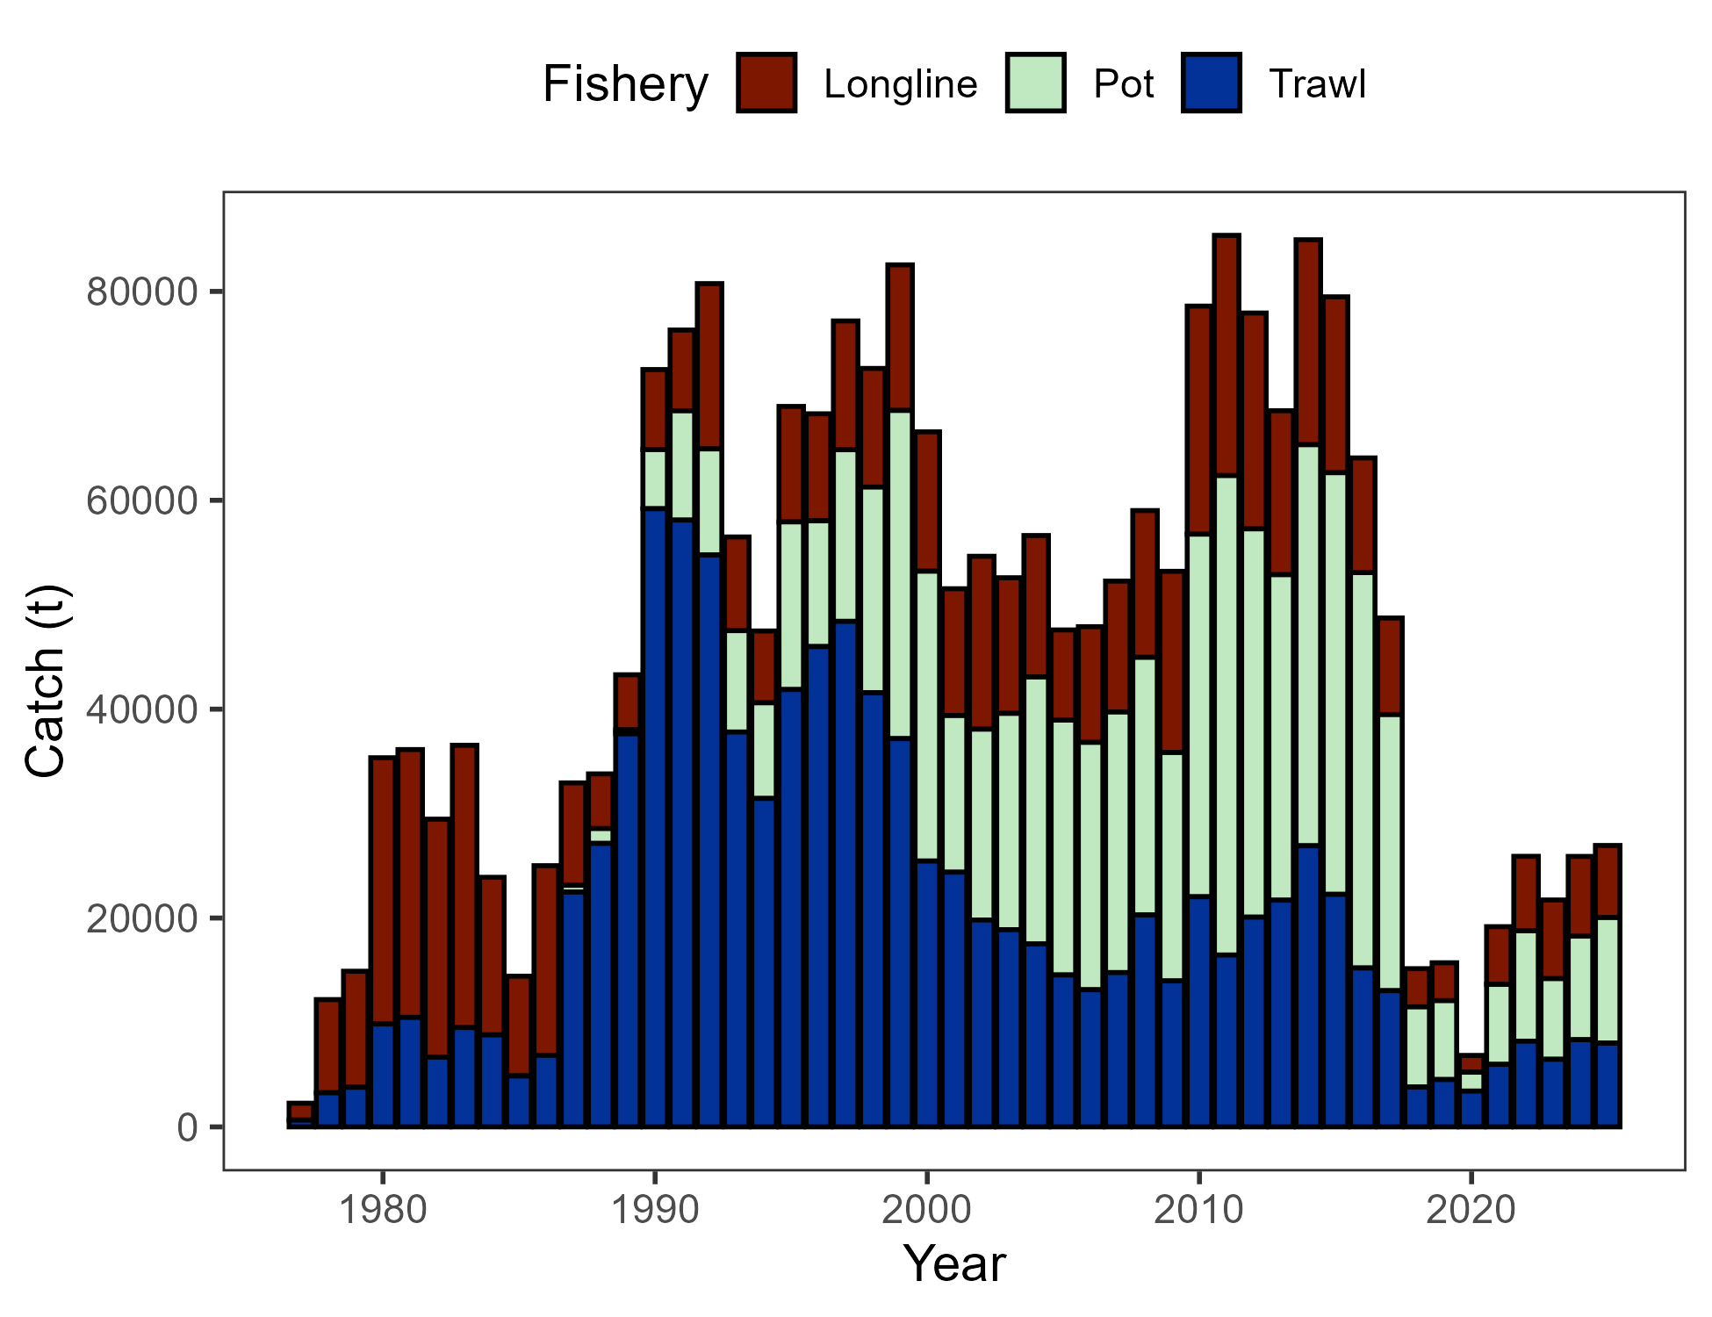

##### Figure 2.1. Commercial catch (mt) of Pacific cod in the GOA in trawl (FshTrawl), longline (FshLL), and pot (FshPot) gear from 1977-2025. Note that 2025 catch was through December 8.

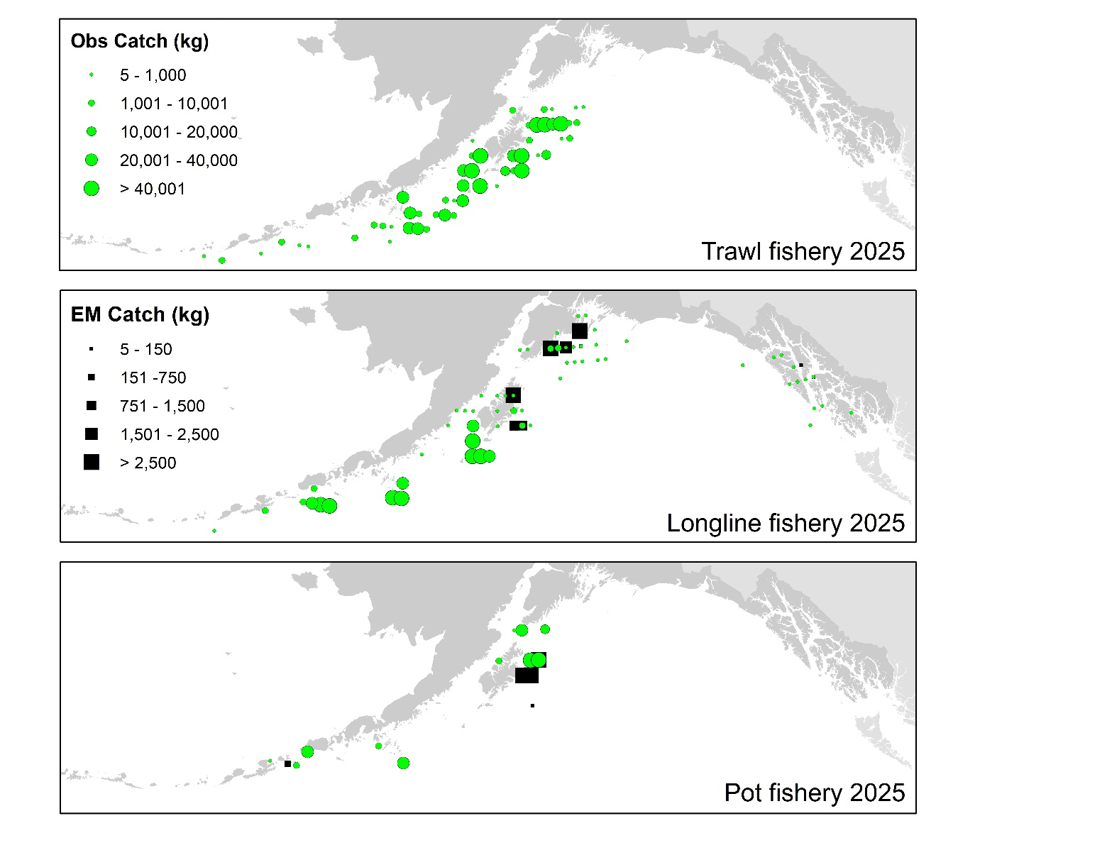

##### Figure 2.2. Observed (Obs) and electronic monitored (EM) commercial catch of Pacific cod in the GOA by 20 km2 grid for 2025. These data include bycatch Pacific cod, but do not include trawl EM data as locations are not yet available.

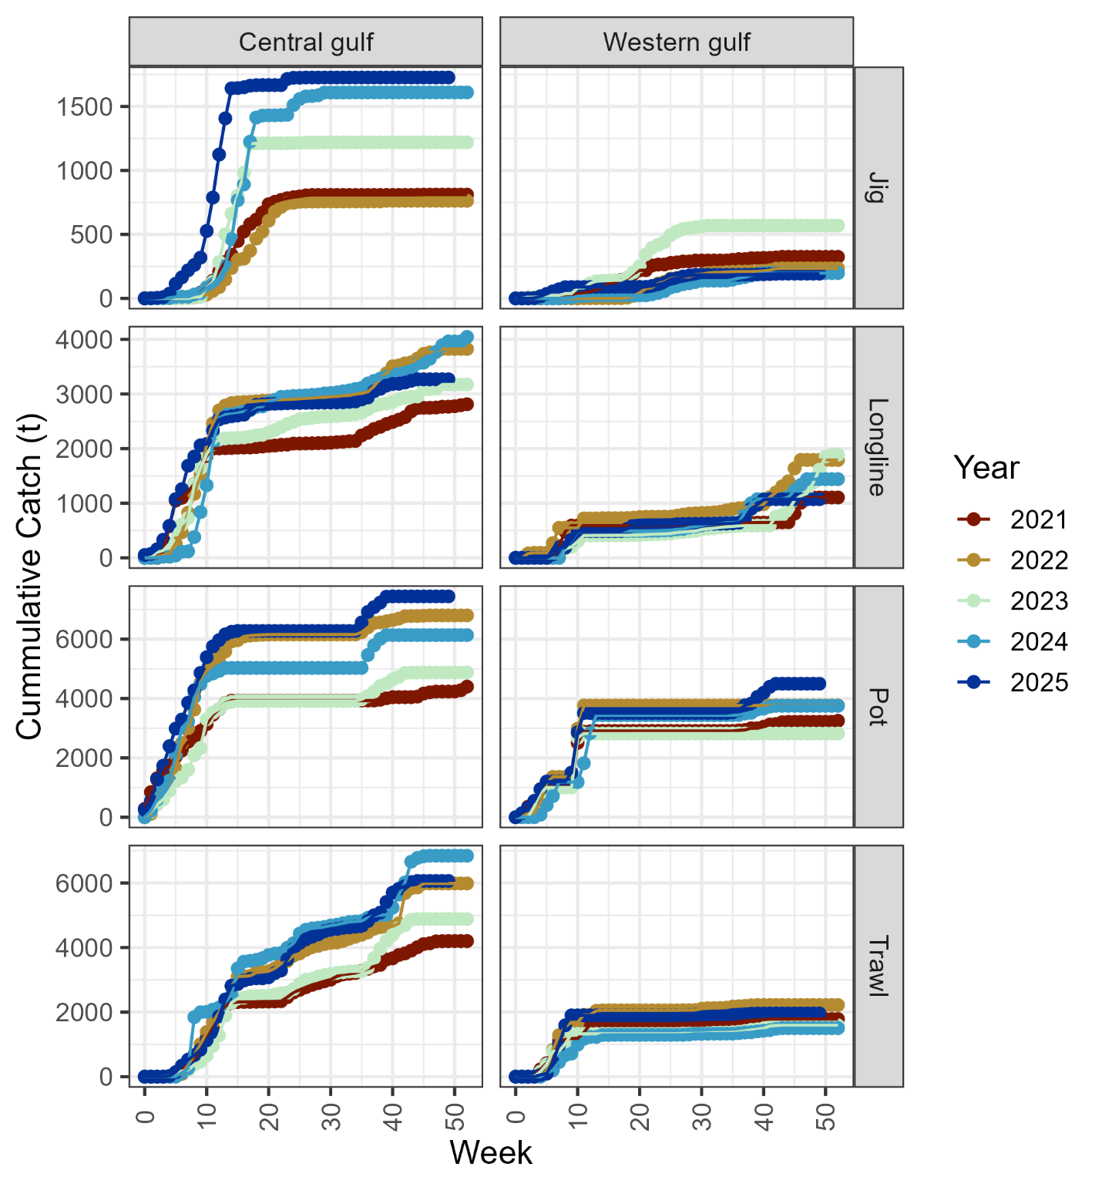

##### Figure 2.3. Cumulative catch week of the year for 2021-2025 by GOA sub-area and fleet (2025 catch through December 8). Note that for the assessment, data from the jig and longline gear were pooled into a distinct fishery.

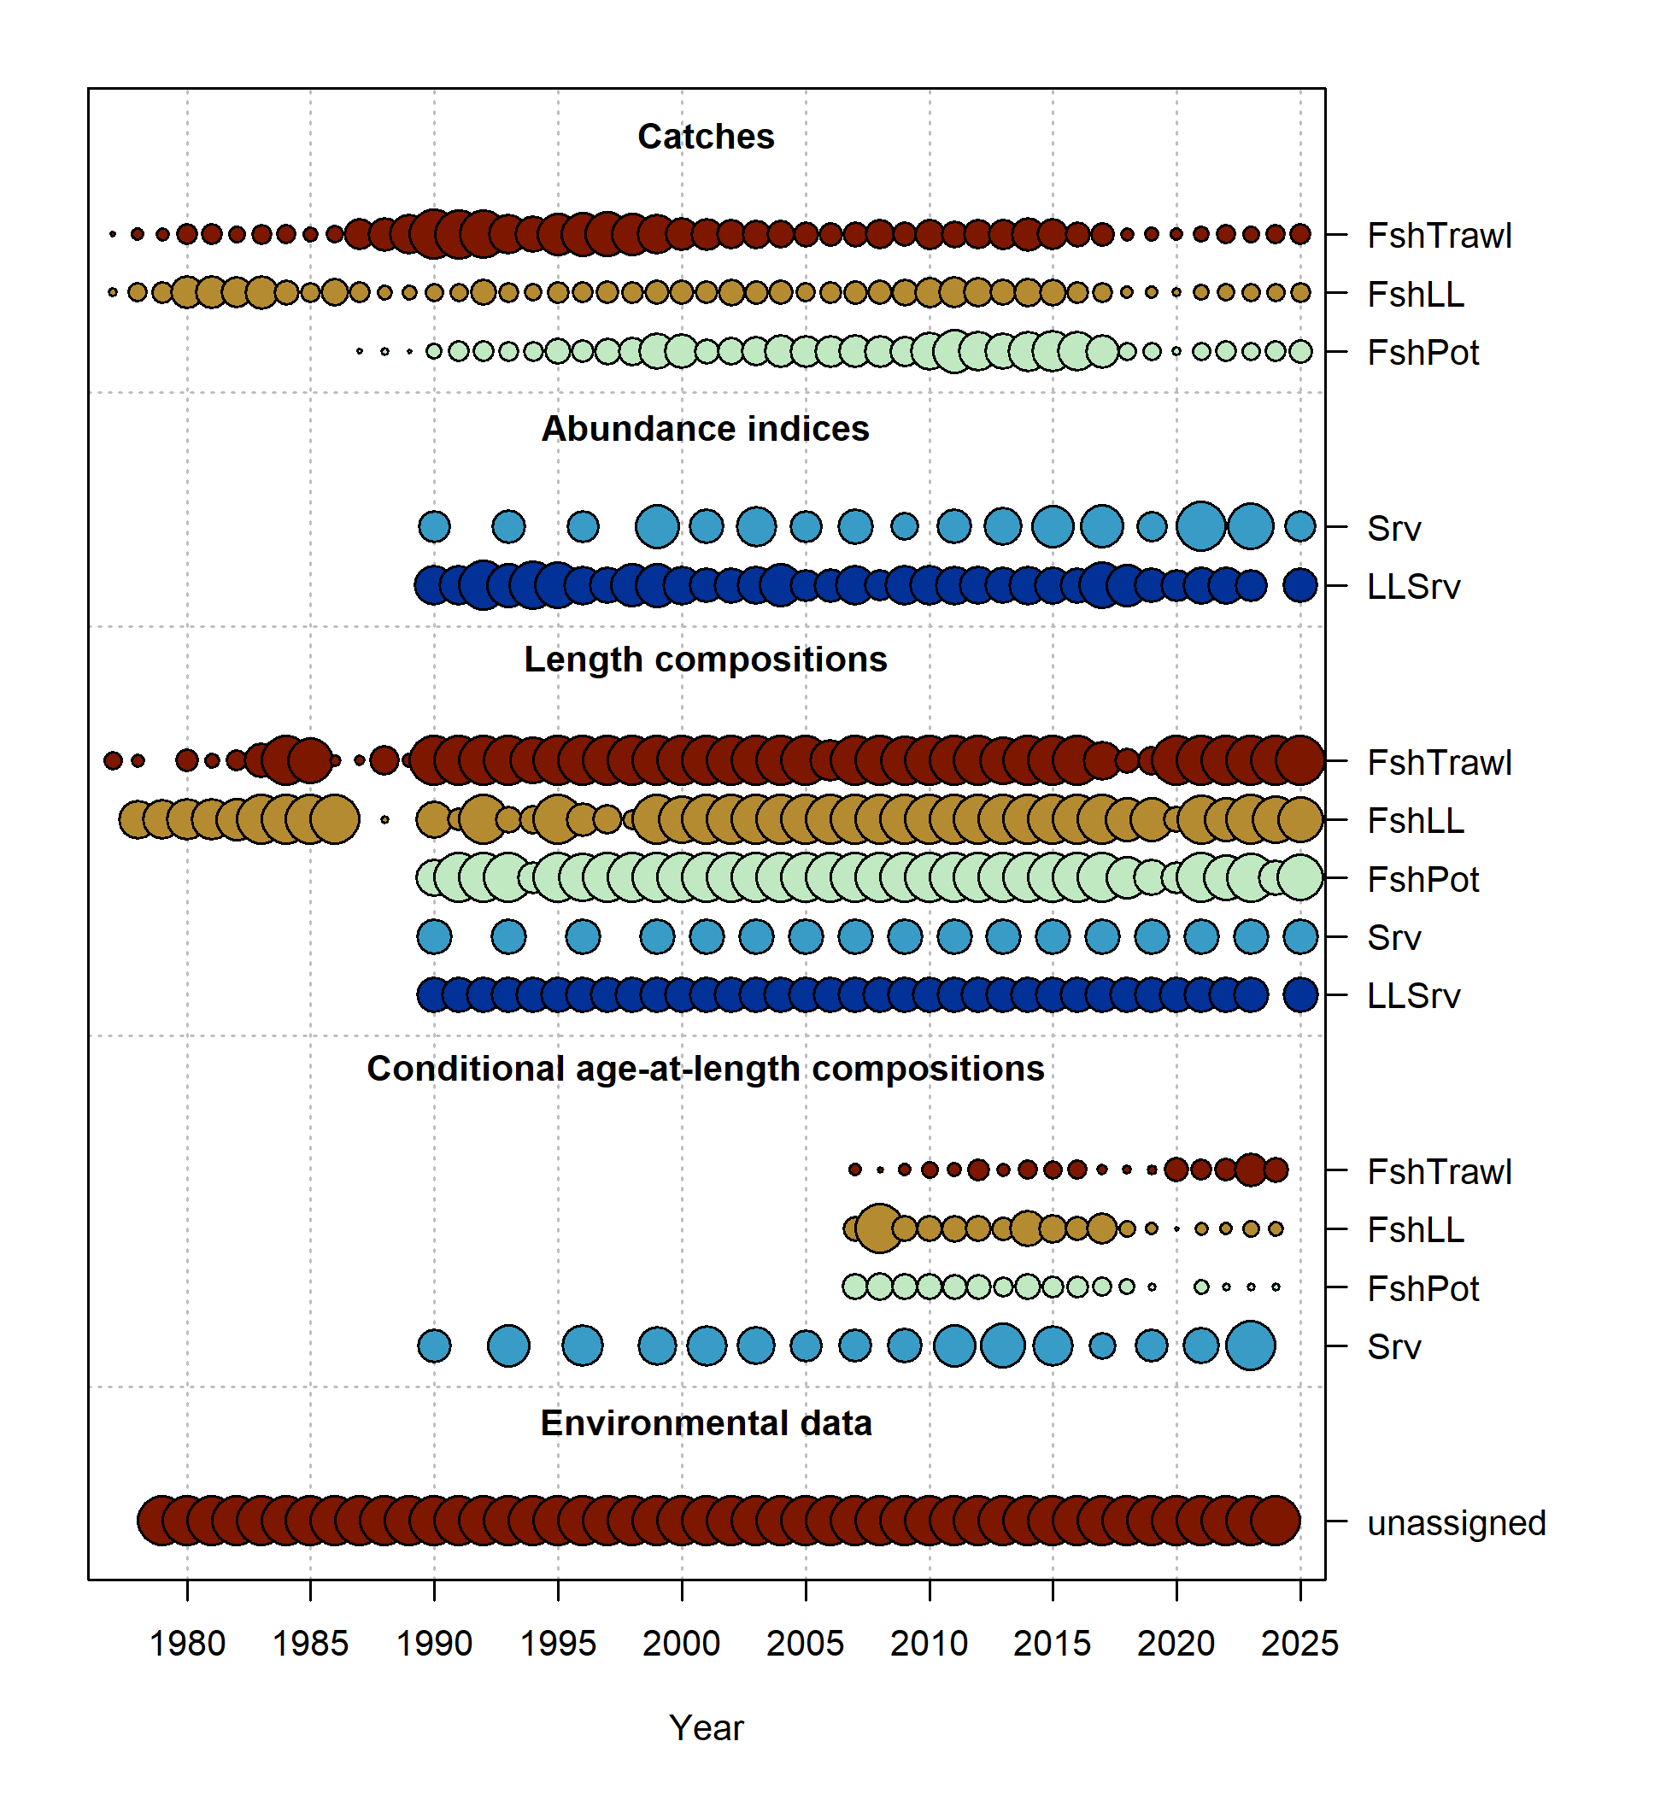

##### Figure 2.4. Data fit in Model 24.0. Circles are proportional to total catch for catches, precision for indices and input sample size for compositions and length-at-age observations. Data sources include fishery data from trawl (FshTrawl), longline (FshLL), and pot (FshPot) fisheries. Survey data include the AFSC longline (LLSrv) and bottom trawl (Srv) surveys. Note that since the circles are scaled relative to maximum within each type, the plots of scaling across dataset types should not be compared.

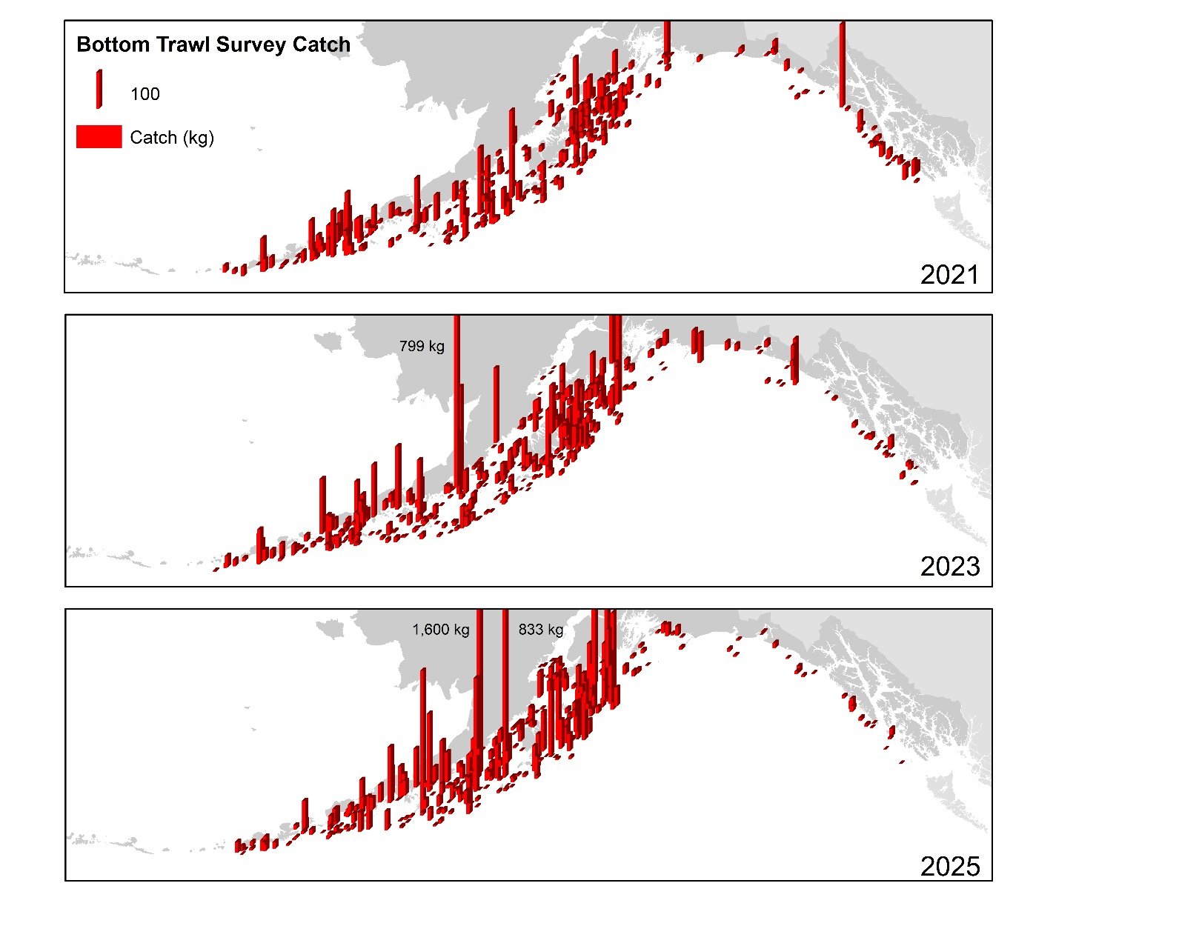

##### Figure 2.5. Distribution of AFSC bottom trawl survey catch (kg) of Pacific cod for 2021-2025.

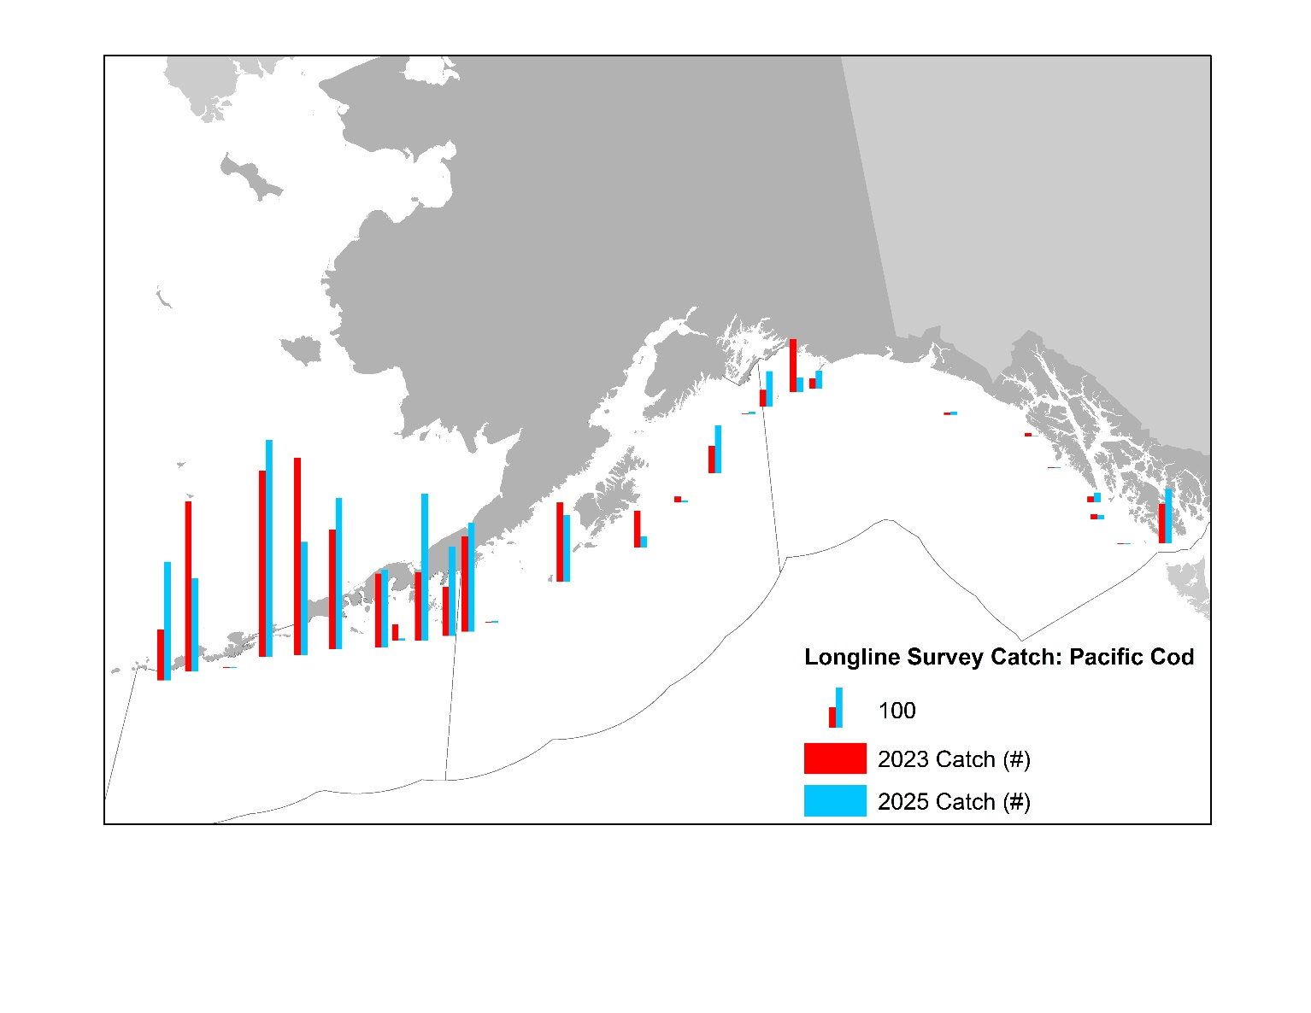

##### Figure 2.6. Distribution of AFSC longline survey catch (numbers) of Pacific cod in 2023 and 2025.

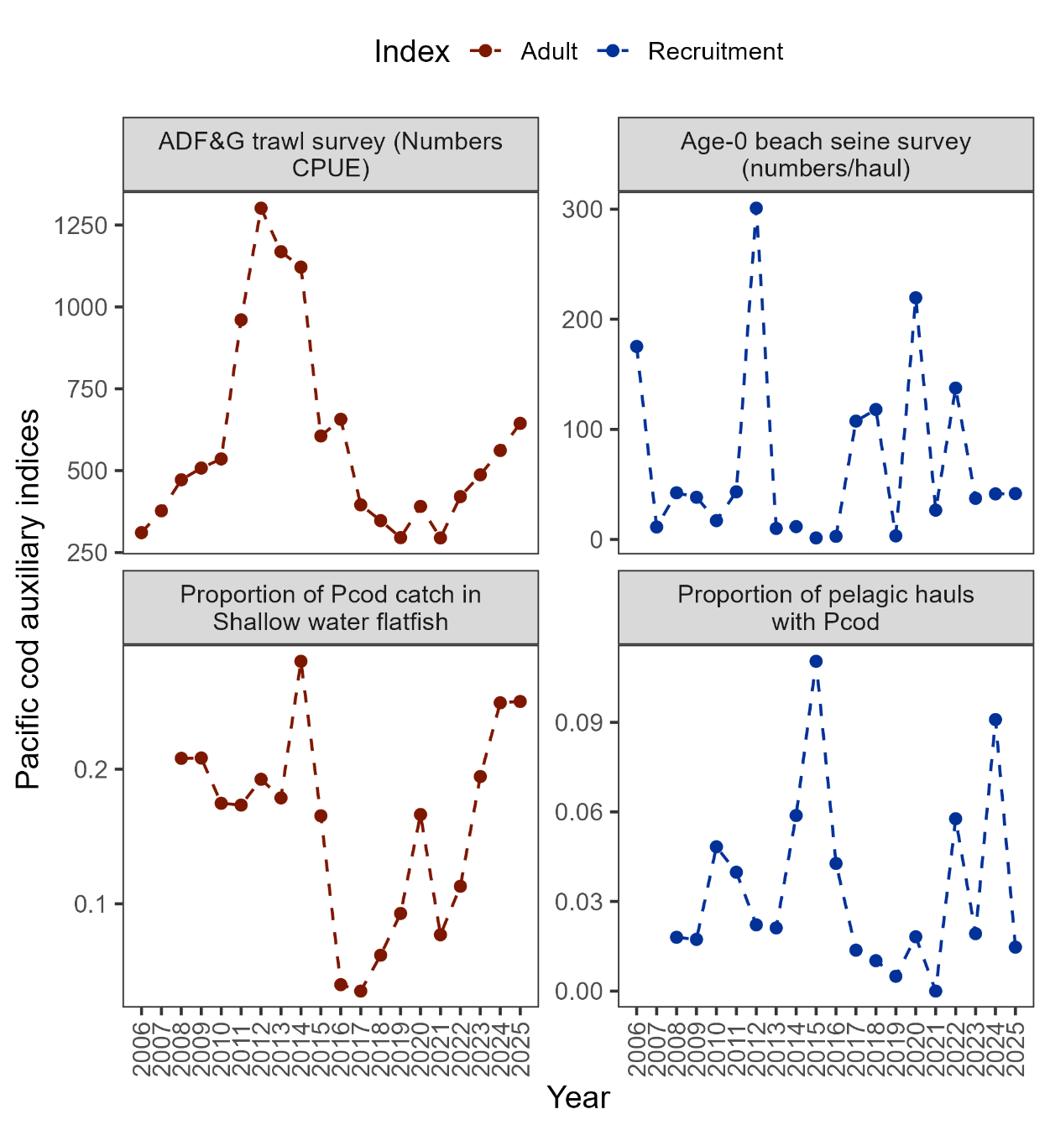

##### Figure 2.7. Auxiliary indices for GOA Pacific cod adult and recruitment abundance that are not used in the stock assessment model. ADFG bottom trawl survey numbers catch-per-unit-effort (top left panel) and proportion of Pacific cod bycatch in the GOA shallow water flatfish fishery (bottom left panel) representing indices for adult abundance, and age-0 beach seine survey numbers per haul (top right panel) and proportion of pelagic trawls in the Central GOA A Season (January-April) walleye pollock fishery with Pacific cod present (bottom right panel) representing indices for recruitment.

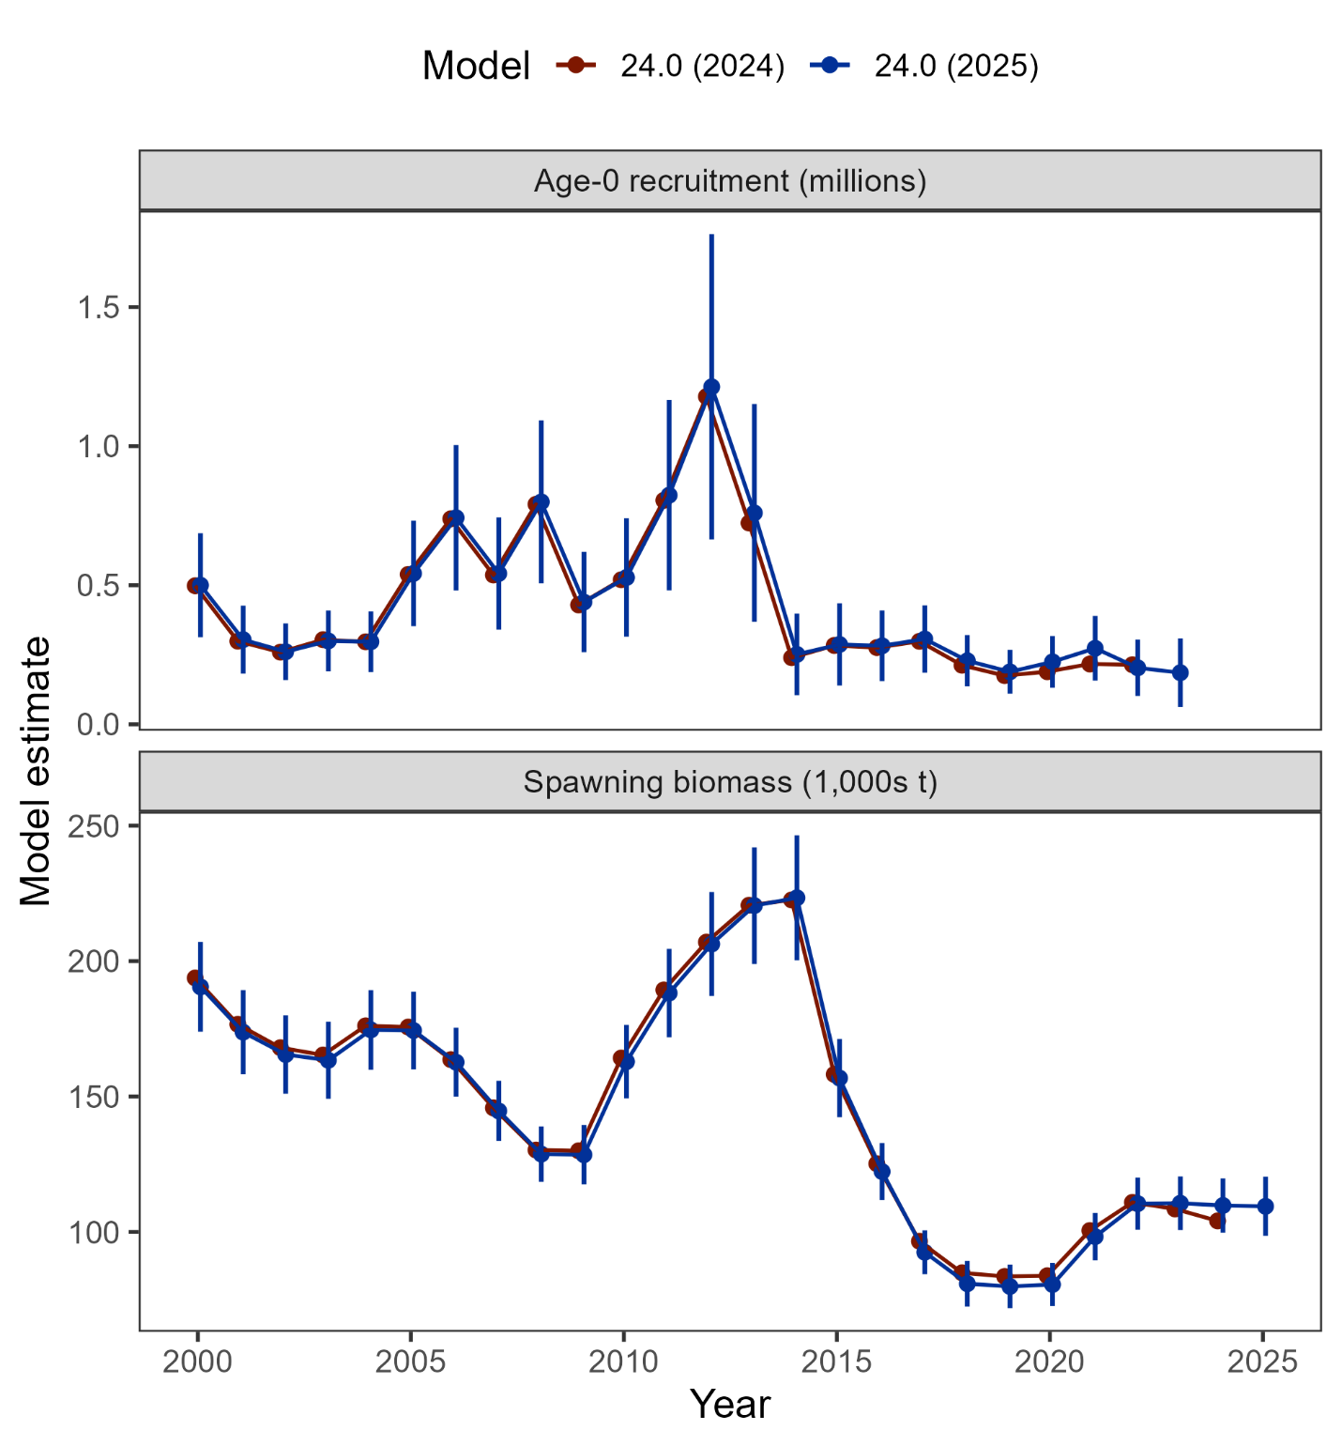

##### Figure 2.8. Comparison of post-2000 recruitment and spawning biomass estimated from Model 24.0 as applied in 2024 and with updated data in 2025 (including 95% confidence intervals).

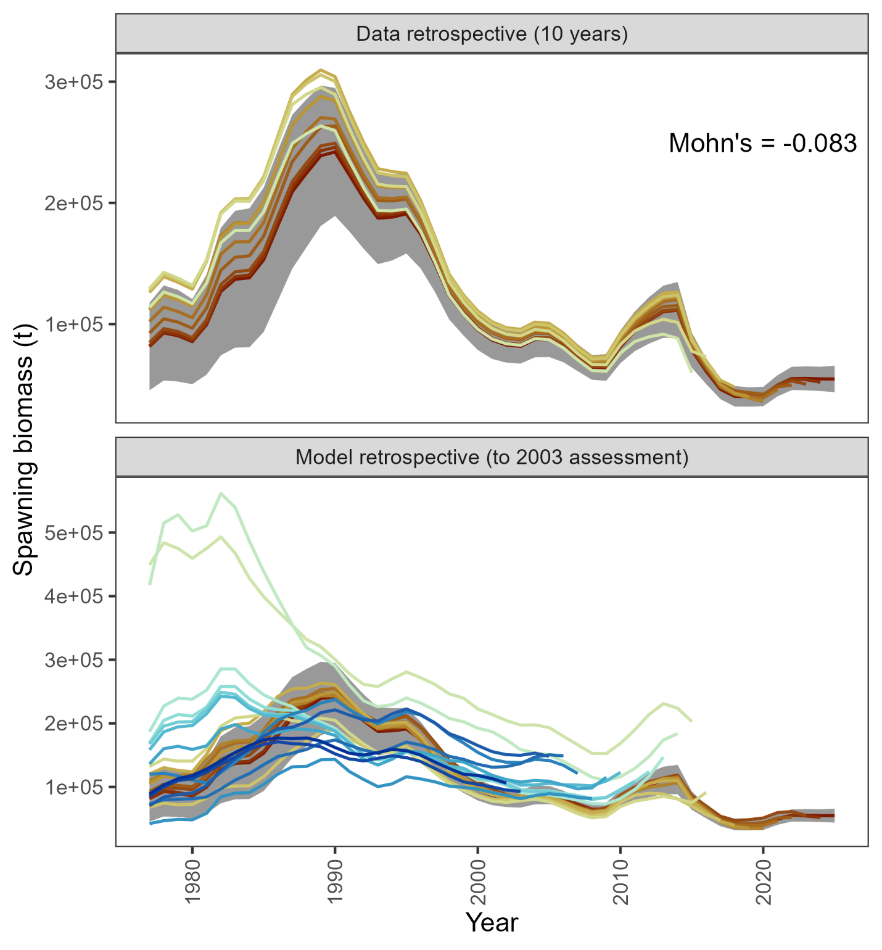

##### Figure 2.9. Retrospective analysis of spawning biomass upon removing data from Model 24.0 as applied in 2025 (top panel) and in comparison to previously accepted models (bottom panel). The shaded region is the 95% confidence intervals from Model 24.0.

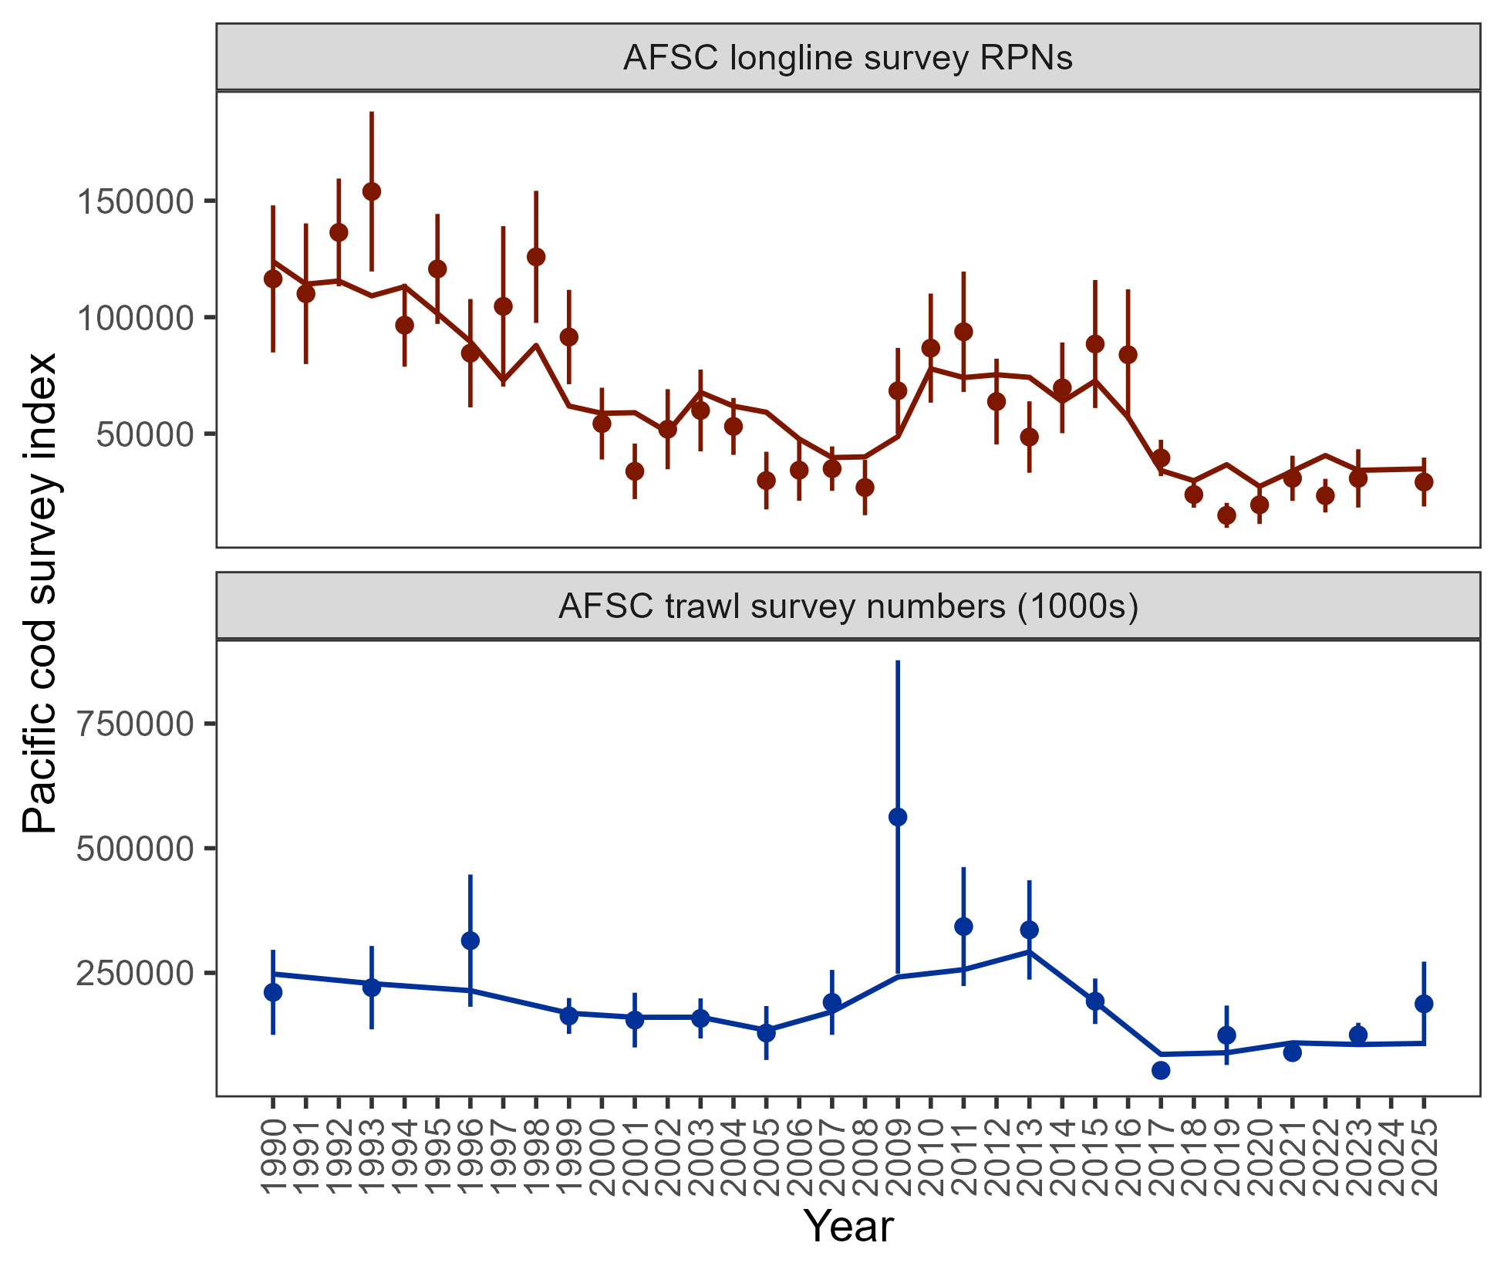

##### Figure 2.10. Population indices fit by the assessment model, including AFSC longline survey relative population numbers (RPN – top panel) and AFSC bottom trawl survey abundance (numbers – bottom panel). Model fit is shown as a solid line and observed data is shown as points (with error bars indicating the 95% confidence intervals).

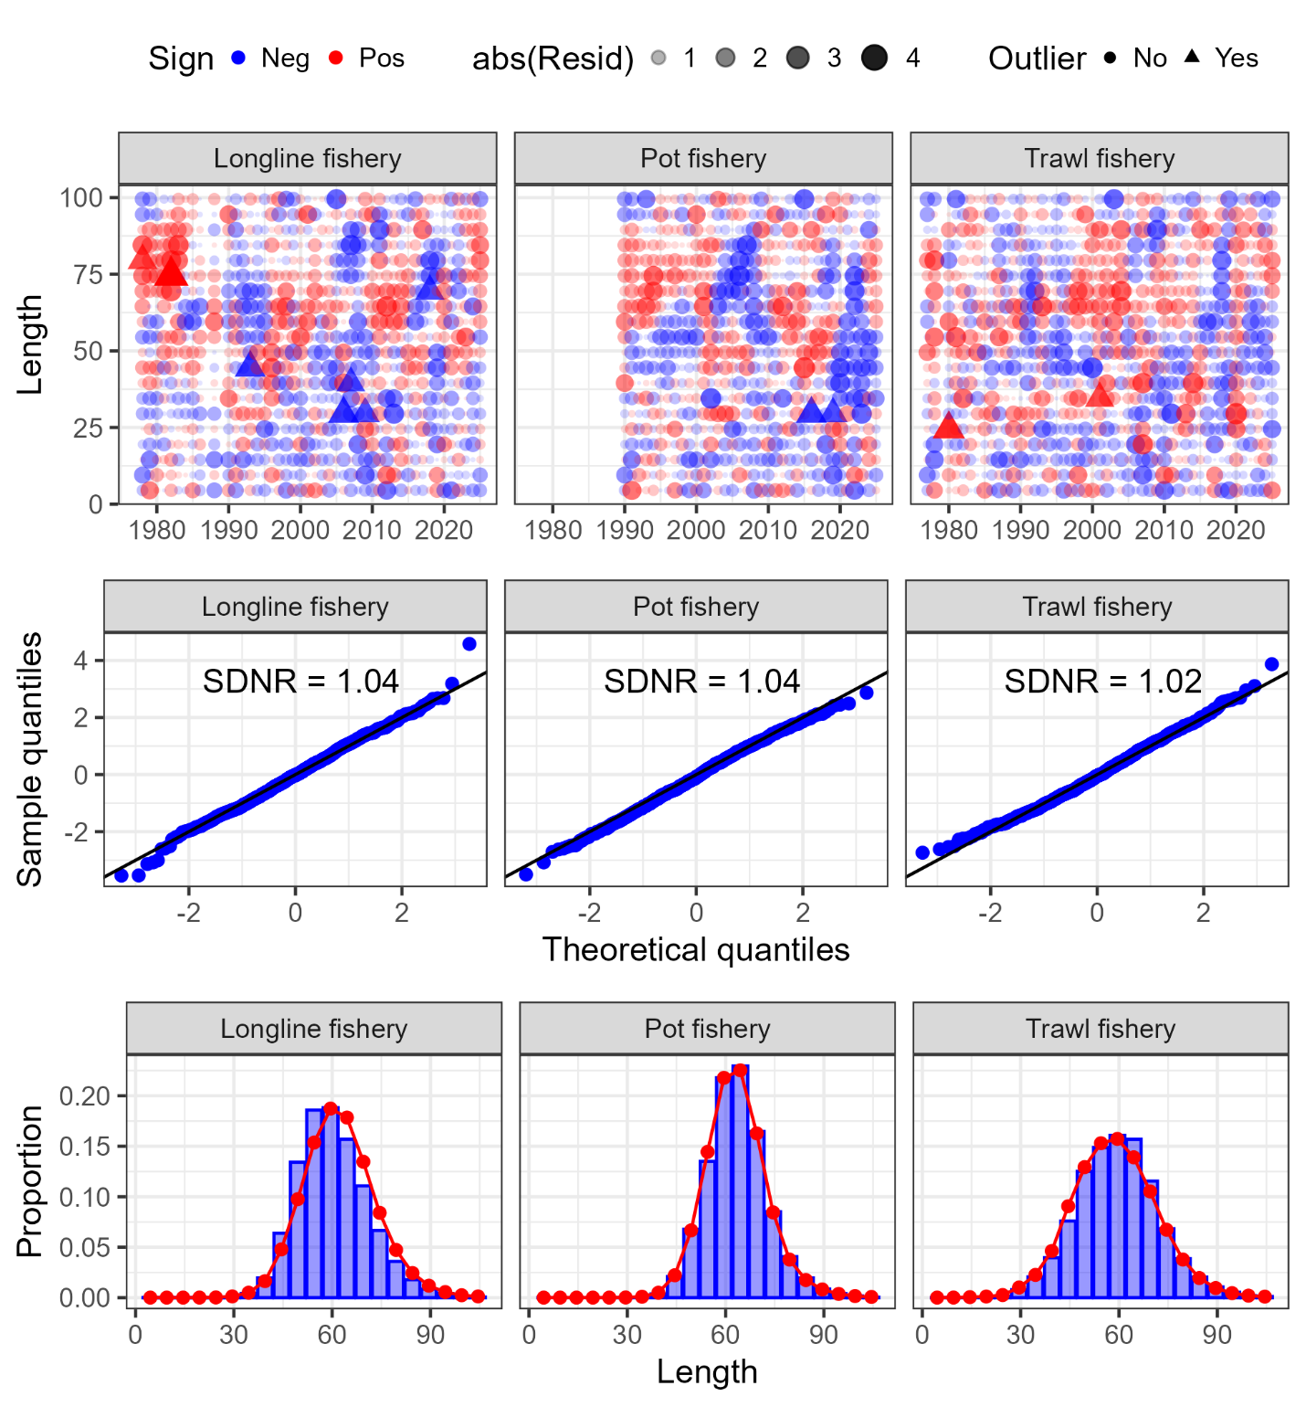

##### Figure 2.11. One-step ahead residuals (top panels), theoretical versus sample quantiles (middle panels), and aggregated model fit (bottom panels) for the fishery length composition data (fleets shown across the columns) fit in the author’s recommended model.

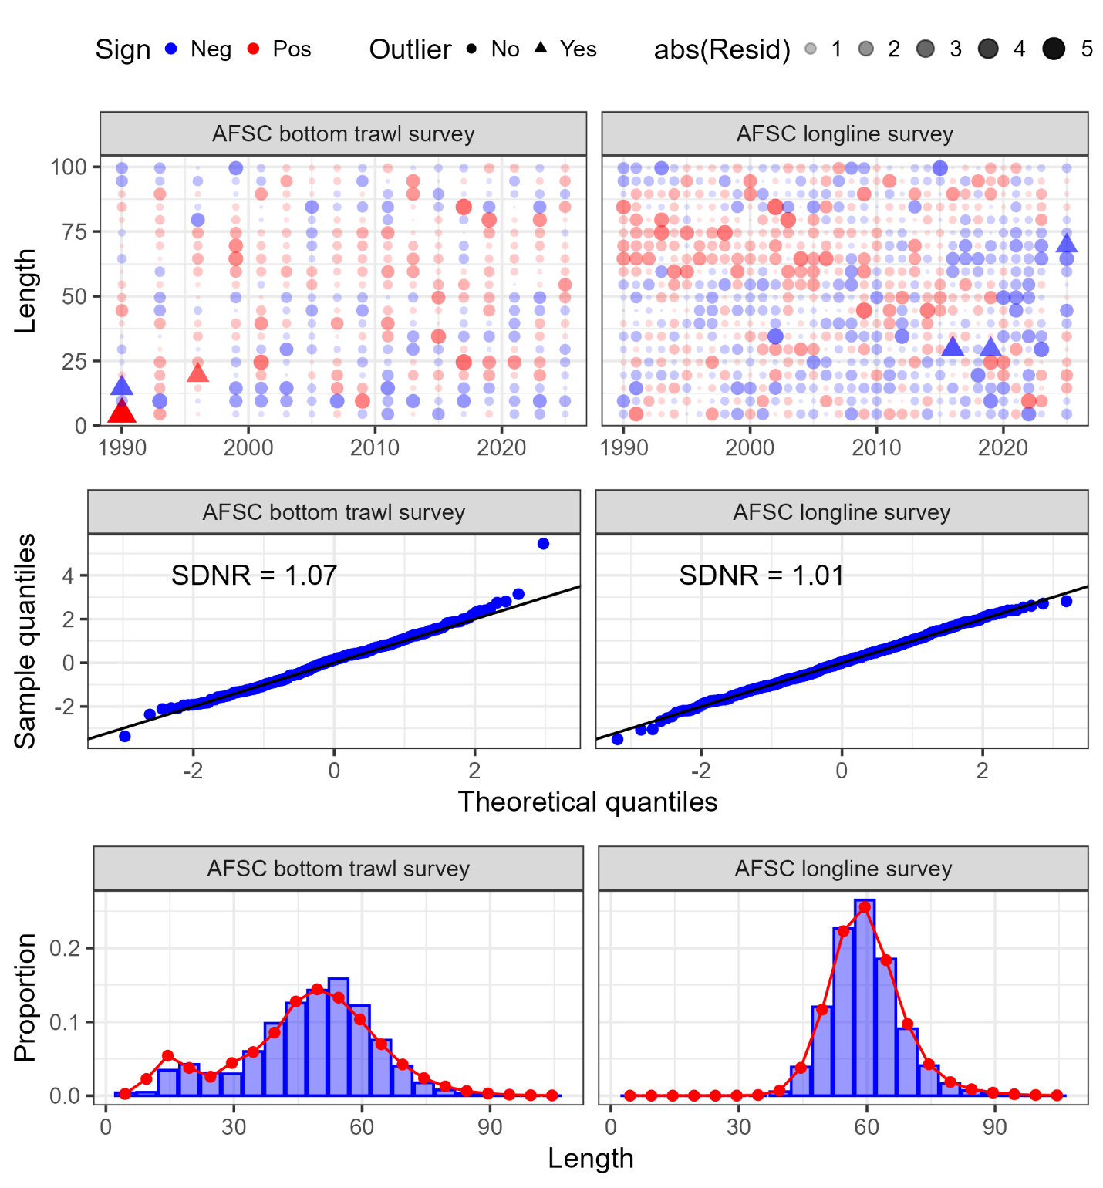

##### Figure 2.12. One-step ahead residuals (top panels), theoretical versus sample quantiles (middle panels), and aggregated model fit (bottom panels) for the survey length composition data (surveys shown across the columns) fit in the author’s recommended model.

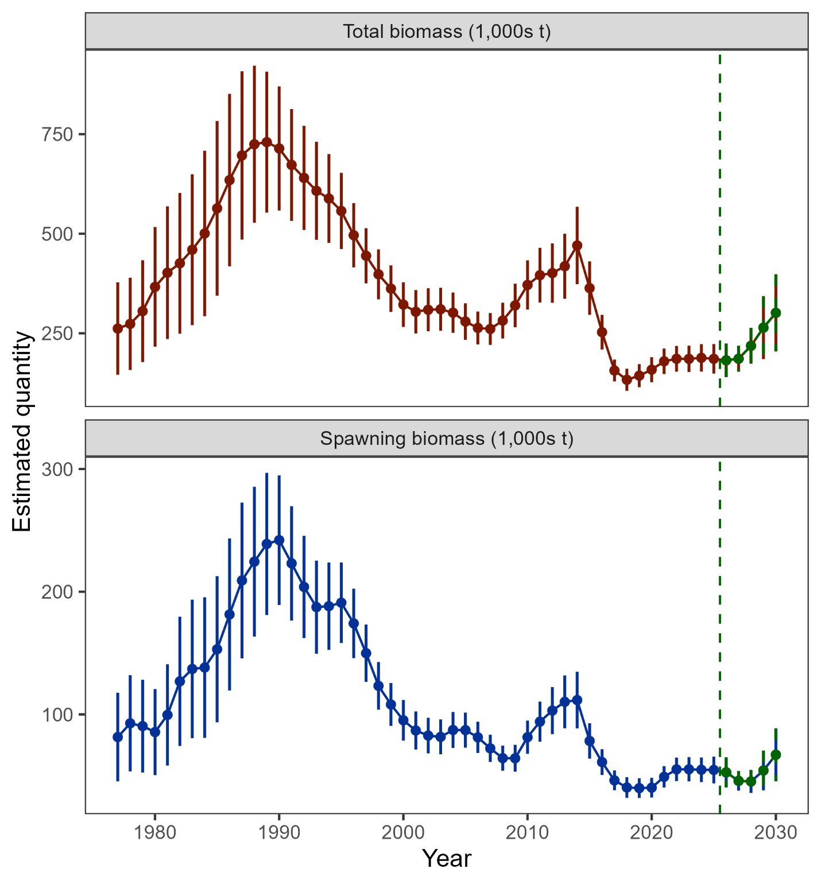

##### Figure 2.13. Estimated total biomass (top panel) and spawning biomass (bottom panel) from the author’s recommended model with 95% confidence intervals. The five-year forecasted biomass values are denoted in green shading and with the vertical dashed line in each plot.

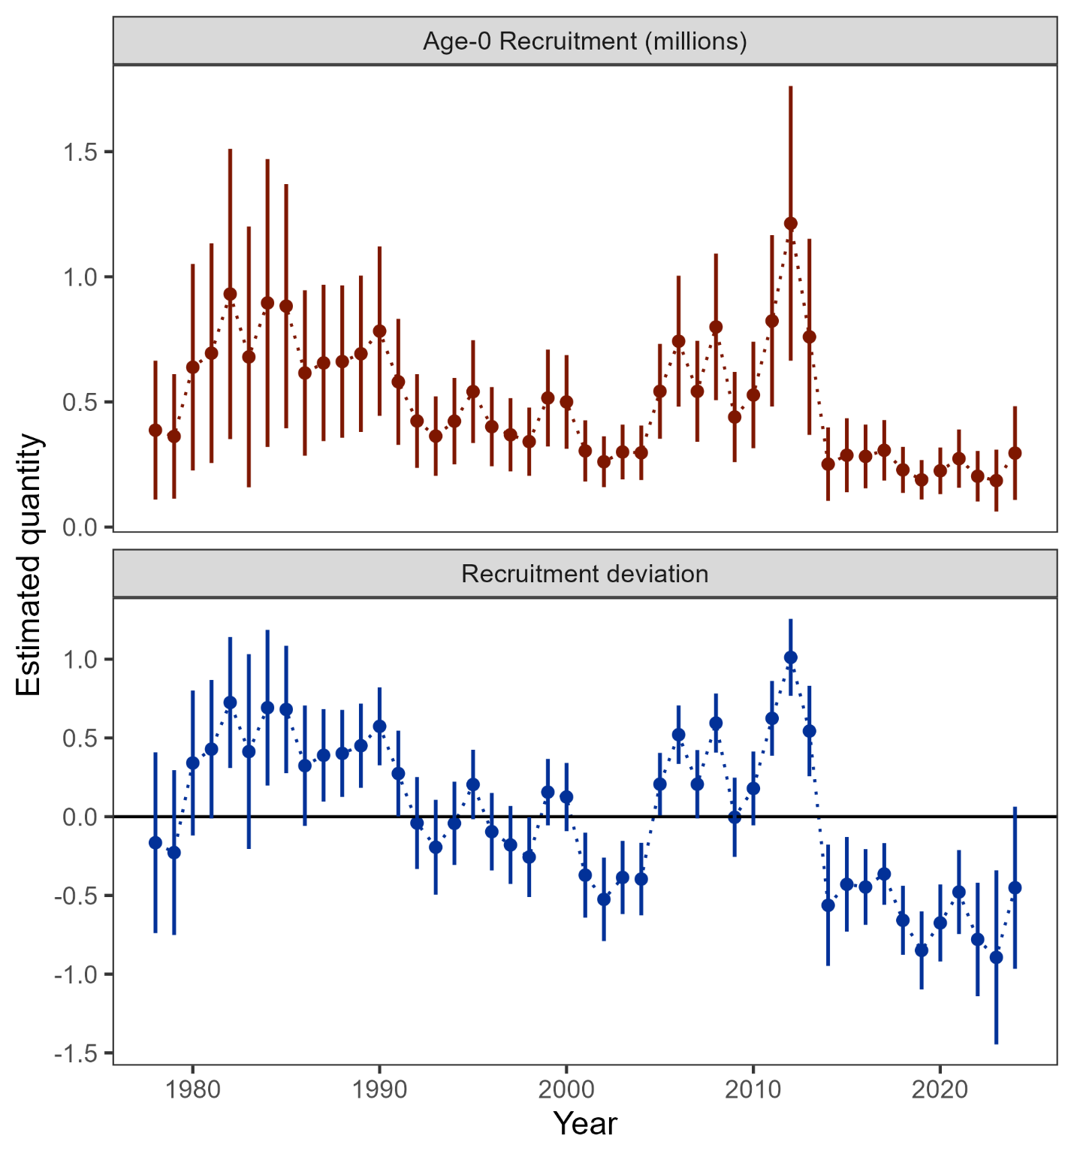

##### Figure 2.14. Age-0 recruitment (top panel) and log recruitment deviations (bottom panel) with 95% confidence intervals from the author’s recommended model.

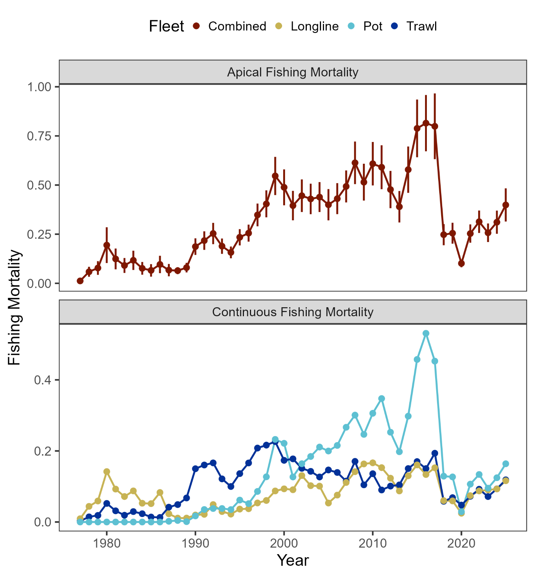

##### Figure 2.15. Sum of apical fishing mortality (top) and continuos fishing mortality by fisheries (bottom).

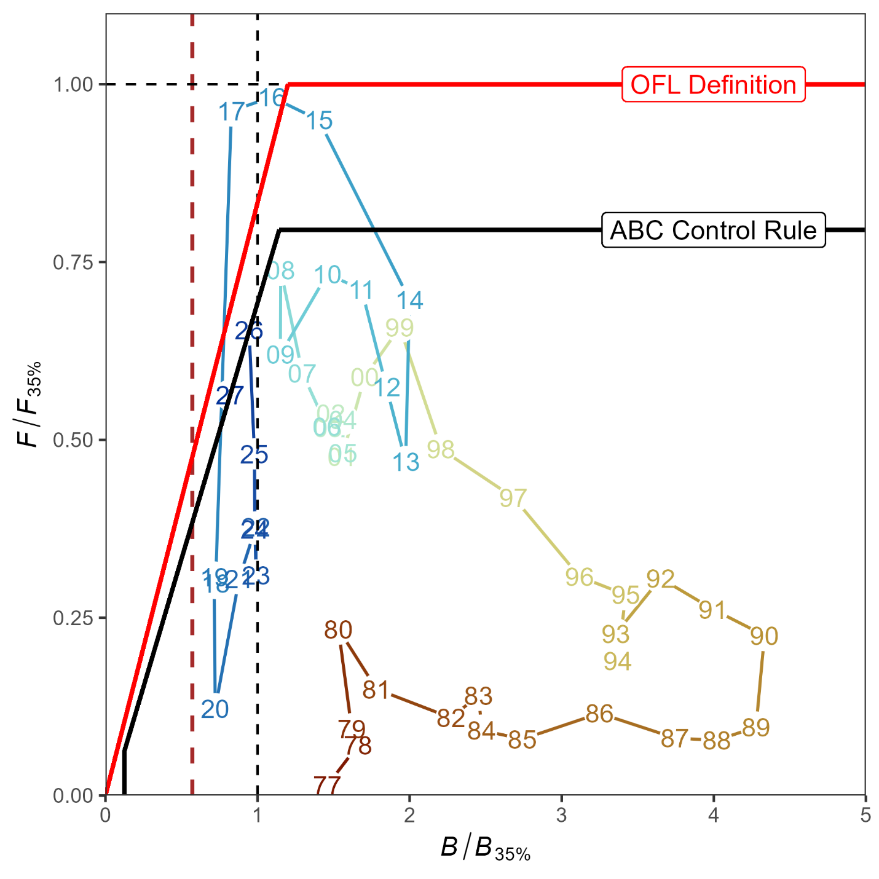

##### Figure 2.16. Ratio of historical *F*/*F35%* versus female spawning biomass relative to *B35%* for GOA pacific cod, 1977-2027. The Fs presented are the sum of the full Fs across fleets. Dashed vertical red line is at B*20%*, Steller sea lion closure rule for GOA Pacific cod.

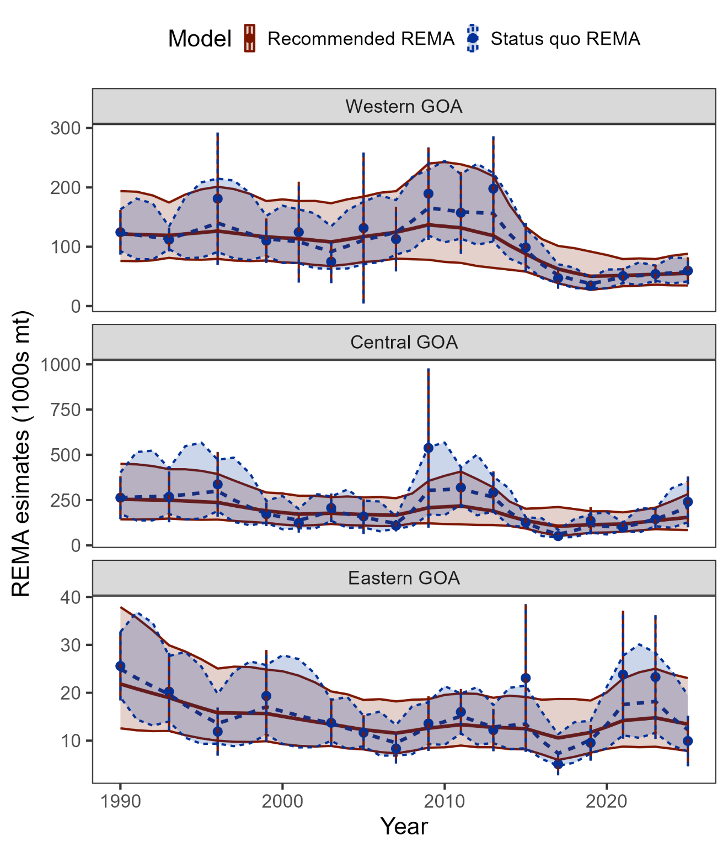

##### Figure 2.17. Recommended and status quo REMA results as fit to the AFSC bottom trawl survey by area.

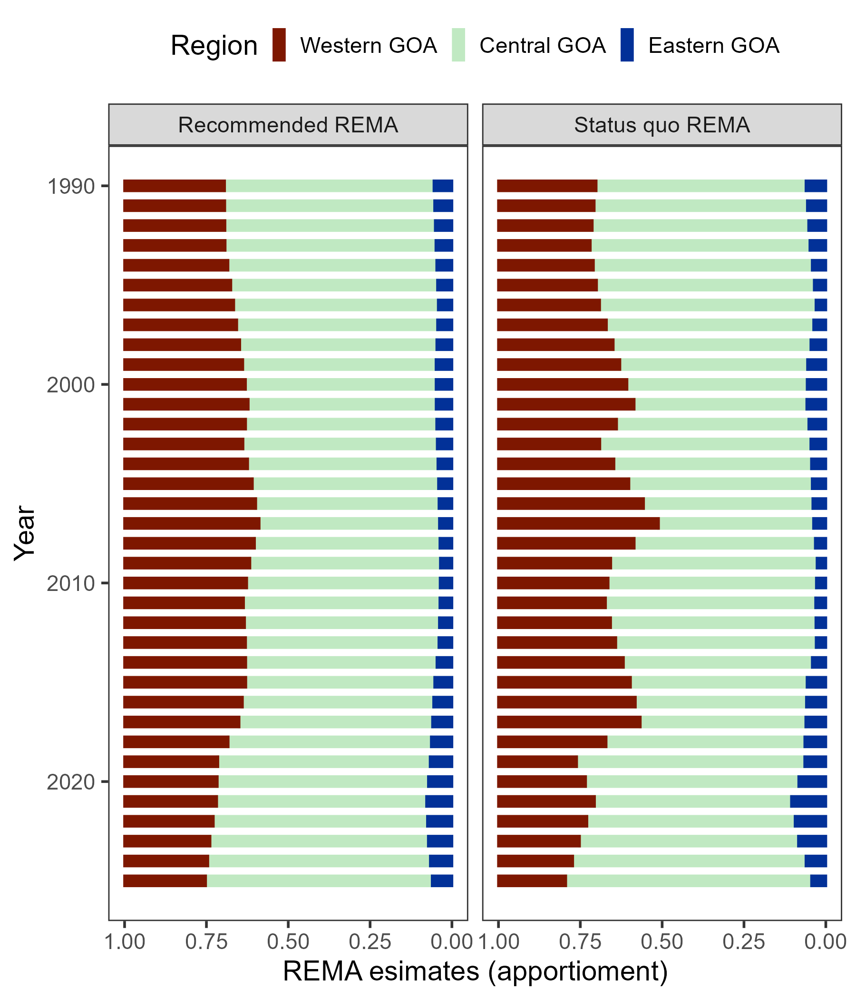

##### Figure 2.18. Recommended and status quo REMA apportionment results.

# Appendix 2.1 Ecosystem and Socioeconomic Profile of the Pacific cod stock in the Gulf of Alaska - Report Card

The ESP can be found at this [link](https://apps-afsc.fisheries.noaa.gov/Plan_Team/2024/goapcod_app1.pdf).

# Appendix 2.2 Analysis of the Gulf of Alaska Bottom Trawl survey restratification for Pacific cod

Pete Hulson, Zack Oyafuso, and Stan Kotwicki

## Executive Summary

In 2025, the Alaska Fisheries Science Center’s (AFSC) Gulf of Alaska (GOA) bottom trawl survey transitioned to a new stratified random design. The survey design from 1990-2023 consisted of 59 strata defined by INPFC management area, depth, and general habitat type (shelf, gully, and slope). The development of a new survey design started in 2019 and has undergone extensive simulation evaluation (Oyafuso et al. 2021, 2022) and review by management bodies (e.g., NPFMC Groundfish Plan Team and SSC) prior to implementation in 2025. This new survey design was implemented to increase sampling efficiency while maintaining unbiased estimates of population indices and composition data that are used within stock assessments conducted by the AFSC. The new survey design now consists of 28 strata defined by NMFS management area and depth.

In this appendix we compared the historical bottom trawl survey’s time-series of design-based estimates of biomass and abundance to what the estimates could have been had historical stations been post-stratified under the new survey design. We use GOA Pacific cod as an example species because it is well sampled and consistently distributed across the continental shelf of the GOA. We find that the historical indices of biomass and abundance are remarkably similar when post-stratified under the new survey design. We conclude that the new survey design of the GOA bottom trawl survey provides consistent estimates with the historical time-series of important indices in both magnitude and trend. Furthermore, the 2025 estimates of biomass and abundance for Pacific cod under the new survey design follow and continue the recent trends observed in the population. We emphasize that the new survey design maintains a robust time-series of indices provided by the GOA bottom trawl survey that are based upon unbiased sampling designs and provide our best information available to understand population trends for stocks assessed within the GOA.

## Data

Data used in this analysis included historical haul-level area-swept CPUE (in kg per km2 for biomass estimation and in numbers per km2 for abundance estimation) from the AFSC GOA bottom trawl survey. The time-series of the surveys investigated were triennially from 1990-1999, then biennially from 2001-2023.

## Analytic Approach

To assess how the restratified survey design might have impacted historical biomass and abundance indices for GOA Pacific cod, we employed a two-step reanalysis. First, historical hauls were spatially reassigned to the strata under the new survey design. Second, we utilized the “survey” R package (Lumley 2024) to re-calculate total survey biomass/abundance and associated variances using post-stratified weights to correctly account for differences in stratum inclusion probabilities of the post-stratified stations. We recalculated total survey biomass and abundance across the GOA-wide region as well as GOA management subregions (Western, Central, and Eastern GOA).

## Results

Reanalysis of the historical GOA bottom trawl survey time-series reveals high consistency between the original time-series and the original time-series post-stratified under the new design (Figures 2.2.1 and 2.2.2). GOA-wide biomass and abundance estimates (Figure 2.2.1) align most closely during periods of lower magnitude (e.g., 1990–2007 and 2015–2023), with minor divergence occurring during peak years (2009–2013), though given the high overlap in the 95% confidence intervals, these divergences do not appear to be statistically meaningful. Comparison of the coefficients of variation results in a mean increase of 0.6% in biomass and 1.4% in numbers after post-stratifying under the new design compared to the original time-series. Since 2015, the two time-series have been nearly indistinguishable. The 2025 indices under the new design continue the established historical trends in both magnitude and direction.

The consistencies between the two time-series also persist at the subregional scale (Figure 2.2.2). With the exception of some slight divergences in the point estimates in the Western GOA (1996, 2009), Central GOA (2009) and the Eastern GOA (1990, 2015), the subregional indices were also very similar between the original and post-stratified time series. Furthermore, in the cases of these years with slight divergences, the high overlap in their 95% confidence intervals suggest these differences are not statistically meaningful. The 2025 Eastern GOA index, while lower than recent years, remains within the historical range of biomass estimates in this subregion.

The remarkable consistency observed in well-sampled stocks like Pacific cod demonstrates that the new design continues an unbiased design for the GOA bottom trawl survey and is functioning as intended. Mismatches between the original and post-stratified estimators are to be expected given the random nature of the sampling process. For species with inherently patchy distributions (e.g., rockfish), no stratification design can fully overcome inherent sampling variability that then translates through to survey indices. Furthermore, for such species, within a reanalysis of historical survey data like undertaken for Pacific cod it is statistically impossible to disentangle the effects of the restratified survey design from the natural variability and "zero-heavy" skewed catch data associated with their distributions.

## Literature Cited

Lumley, T.. 2024. “survey: analysis of complex survey samples.” R package version 4.4.

Oyafuso, Z. S., L. A. K. Barnett, and S. Kotwicki. 2021. Incorporating spatiotemporal variability in multispecies survey design optimization addresses trade-offs in uncertainty. ICES Journal of Marine Science 78, 1288–1300.

Oyafuso, Z., L. A. K. Barnett, M. Siple, and S. Kotwicki. 2022. A flexible approach to optimizing the Gulf of Alaska groundfish bottom trawl survey design for abundance estimation. NOAA technical memorandum NMFS-AFSC ; 434.

## Figures

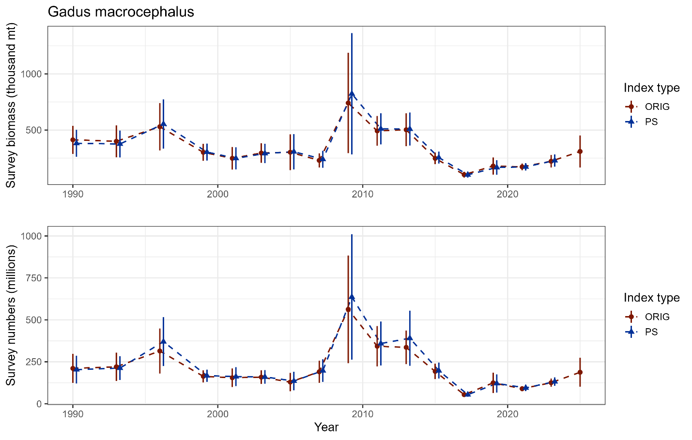

##### Figure 2.2.1. GOA bottom trawl survey population indices for Pacific cod from the original design-based estimates (ORIG) and the reanalyzed design-based estimates (PS) under the new survey design.

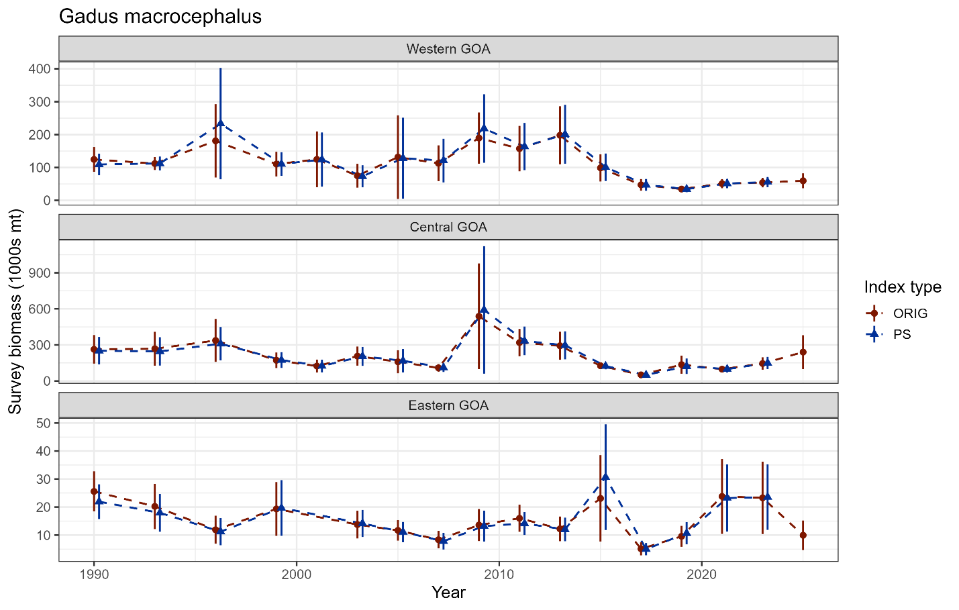

##### Figure 2.2.2. GOA subregion bottom trawl survey biomass indices for Pacific cod from the original design-based estimates (ORIG) and the reanalyzed design-based estimates (PS) under the new survey design.